**FPGA-Based RISC-V Instruction Set Development**

Submitted by

**Yang Zihao**

3036120117

*M.Sc.(Eng.)*

A dissertation submitted for the degree of

Master of Science in Engineering

At the

Department of Electrical and Electronic Engineering

The University of Hong Kong

In

July 2023

# DECLARATION

I am Yang Zihao, and I hereby declare that this thesis represents my own work, except where due acknowledgement is made, and that it has not been previously included in a thesis, dissertation, or report submitted to this University or any other institution for a degree, diploma or other qualifications.

Signed

DECLARATION 2

ACKNOWLEDGEMENT 4

Chapter 1: Introduction 6

1.1Background 6

**1.1.2 RISC vs CISC** 13

**1.1.3 Types of Instruction Set** 15

1.2 Literature Review 17

**1.2.1 Hard-Core Implementation vs Soft-Core Implementation** 17

**1.2.2 RISC-V Instruction Set Microprocessor Architecture** 20

**1.2.3 Harvard and Von Neumann Architecture** 24

**1.2.4 Logical and Arithmetic Unit** 30

1.2.5 State Machine 38

2. Digital system Design 39

2.1 Microprocessor-based System for Remote Car Control 39

2.2 IR transmitter 47

2.3 VGA Display 53

2.4 PS/2 and Mouse Driver 58

2.5 7-segments LED 62

2.6 Interrupt 66

2.7 Rom 68

2.8 RAM 70

3.Software Application and Test Result 74

3.1 Assembly code and machine code 74

3.2 Machine code 76

3.3 Demo and Resource Cost 83

4, Conclusion 85

Reference 86

# ACKNOWLEDGEMENT

Since I officially became a postgraduate student at the School of Electronic and Electrical Engineering of the University of Hong Kong on September 1, 2023, I have met many smart and friendly classmates and teachers who have given me a lot in academic and life, and completed many interesting projects. As graduation is approaching, I would like to extend my deepest gratitude to the many individuals who have supported me to overcome the academic and life’s difficulties. Without their guidance, encouragement, and unwavering support, I would not have been able to graduate successfully.

First of all, I would like to thank Dr David and Steve. Although you are very busy and don’t have much time to guide my project, you guided me in the FPGA accelerated quantitative finance project of high-frequency trading and the project of developing a five-stage pipeline microprocessor based on RISC-V instructions in your precious free time. Dr. David is also my lecturer of analog integrated circuits. You are humorous and focus on cultivating my underlying logical thinking and trade-off ideas for analog circuits. You taught me to use LTSpice to build LDO, completed my first analog circuit project, and experienced the fun of analog circuit design. Secondly, I need to be grateful for all the university staffs and lecturers of the department of Electronic and Electrical Engineering of the University of Hong Kong. Because of their professional and careful teaching, it makes me gain professional digital analog IC and high-performance computer architecture knowledge and accumulate professional skills and remarkable project experience. I also need to thank my roommates Luo Junyao and Hu Shuhuan. The three of us ate together, played football, played games, and studied together. I am very lucky to meet you at the University of Hong Kong. You gave me a great dormitory life experience. My friends Lan Juncheng and Li Wenle, you selflessly helped me during my autumn recruitment, helped me with advice, shared information, and played Apex together to relax. It can be said that my study, job search, and internship at Pingtouge semiconductor were so smooth because of you.

Eventually, it is necessary to thank my parents Yang Weixing and Li Xiaoyun. Mom and Dad have given me so much love and support in my 25 years of life. Because of my mistakes, I spent two more years to correct them. Mom and Dad have always trusted me, supported me, cared about me, believed in my dream of pursuing a doctorate without any complaint, and gave me financial support for my postgraduate studies. I know that Dad, you like to drive a Benz vehicle, but for my dream, you gave up your dream of changing cars without complaint. I also know that mom, you worried about my future many times at nights, and saved money for my postgraduate studies. You who love beauty so much have aged a lot in the past two years since you care my career and life. In the future, I will do my best to repay Mom and Dad's love. I also have a special person to thank, and that is you, Miss Feng Tianyi. Although we have separated, when I think back to the past three years we have been together, even though we had many quarrels, we have experienced many sweet times after all. We started in Yunnan Garden on the Mid-Autumn Festival in 2021. After I made a big mistake, you were the only one who supported me behind my back. When I was alone in a rental house in Shanghai and crying because of the failure of my application, it was you who had been encouraging and supporting me and helped me through the most difficult time in my life. We looked forward to the future together in a small house in Shenzhen, witnessed love together under the fireworks at Disney, and ate at restaurants near baicaoyuan together, which was a place full of your memories. Although we are very incompatible in character and my mistakes hurt you and led to our separation, I still want to say thank you and sorry to you here. You will always be the most important person in my life in these three years.

Finally, looking forward to the future, I hope that I can continue to learn and grow in the field of digital chips, find a like-minded partner, and live a happy life. This year of postgraduate study at the University of Hong Kong, I have sweet memories, which will be my lifelong wealth.

**ABSTRACT**

The flexibility and open-source nature of the RISC-V instruction set architecture (ISA) have made it an attractive choice for FPGA-based development, enabling customized and optimized hardware solutions. This paper presents an in-depth exploration of the design and implementation of a RISC-V based processor on an FPGA platform. We begin by discussing the key features of RISC-V that make it particularly suitable for FPGA development, such as its modularity and extensibility. The design process is described, including the development of a RISC-V instruction set based microprocessor and the integration of peripheral interfaces tailored for remote car control requirements including VGA display, Mouse Transmitter, Rom, Ram, IR transmitter, LED display, 7-segment modules.

I detail the hardware description language (HDL) coding, synthesis, and place-and-route processes, and provide insights into the optimization techniques used to balance performance, resource utilization, and power consumption. Additionally, the verification and validation methodologies are outlined, employing both simulation tools and on-chip testing to ensure functional correctness and reliability.

All in all, I design the RISC-V based microprocessor systems to realize remote toy car control and prototype them on to FPGA hardware using a standard hardware description language and software algorithm programming.

**Keywords**: Embedded Digital System Design, Embedded Processor Programming, Verilog, Data path and Control Path design, Hardware-Software Co-design

# Chapter 1: Introduction

## 1.1Background

The RISC-V architecture is an (ISA) publicly available instruction set architecture that has recently garnered substantial interest because of its adaptability, modular design, and extensibility. Unlike proprietary architectures, RISC-V provides access to its blueprints, allowing for extensive customization according to user needs. This open-source nature enables engineers to develop microprocessors that satisfy different specific applications and scenarios. Consequently, RISC-V has seen adoption across various industries, from IoT devices with embedded systems and to high-performance computing CPU and GPU or NPU for the development of artificial intelligence like LLM. The advantages of using RISC-V include cost-effective custom processors, the potential for innovative applications, and robust security features. Many consider this technology to represent the future of processing, offering users significant customization capabilities.

* + 1. **RISC-V Microprocessor’s History**

RISC-V is an open standard instruction set architecture (ISA) which is becoming increasingly popular among the world of computer science and engineering. Its development has been influenced by a variety of factors and milestones over the years, making it a remarkable and important player in the evolution of computer architecture technologies.

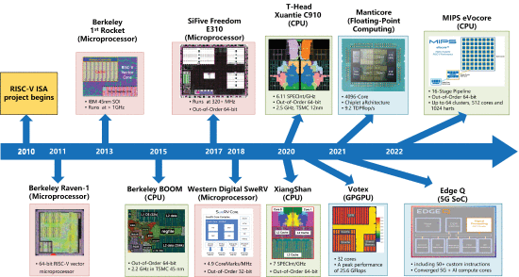

Figure 1: RISC-V Processor Evolution [1]

Early Beginnings and RISC Concept

The begining of RISC-V can be traced back to the broader development of Reduced Instruction Set Computer (RISC) architectures. The RISC philosophy, which emphasizes a simplified set of instructions to enable more efficient processor design and implementation, emerged in the 1980s. It was championed by academic projects like the Stanford MIPS (Microprocessor without Interlocked Pipeline Stages), the IBM 801, and the RISC (Reduced Instruction Set Computer).

RISC-V itself was come up with at the University of California, Berkeley in 2010. Professors David Patterson and Krste Asanović initiated the project as a part of their research on parallel computing. Patterson was already well-known for his earlier contributions to the RISC design with Berkeley RISC in the 1980s. The primary motivation for RISC-V was to create a simple, clean-sheet RISC instruction set that was open and free from the complexities and licensing restrictions associated with other commercial ISAs.

Key Milestones in RISC-V Development

Initial Design and Implementation (2010–2011):

The initial development of RISC-V was focused on creating a minimalist ISA that could serve as a base for both research and practical applications. Early implementations were tested and refined to ensure the robustness and flexibility of the instruction set.

Public Release and Adoption (2014):

The first public release of the RISC-V spec took place in 2014. This release included the base integer instruction set besides optional extensions for multiplication and atomic operations. This marked the beginning of wider interest and adoption in the academic and industrial communities.

Formation of the RISC-V Foundation (2015):

In 2015, the RISC-V Foundation was built to improve and accelerate the development of the RISC-V ISA. The foundation quickly garnered support from a wide range of companies, educational institutions, and researchers, cementing RISC-V's position as a serious contender in the processor design space.

Improvement and Extension of the ISA (2015–Present):

Following the formation of the RISC-V organization and community, the ISA has seen significant development and refinement. New extensions have been introduced to support floating-point arithmetic, vector operations, bit manipulation, and other functionalities. The community-driven approach has ensured that enhancements are well-documented and aligned with user needs.

Over the years, numerous companies have adopted RISC-V for their products and solutions. Key industry players like Nvidia, Western Digital, and SiFive have integrated RISC-V into their product lines, leveraging its flexibility and openness to drive innovation.

Today, RISC-V is seen as a viable alternative to proprietary ISAs like x86 and ARM. It is lauded for its simplicity, flexibility, and open licensing model, which reduces barriers to entry for hardware innovation. The RISC-V ecosystem includes a variety of tools, compilers, simulators, and design resources that make it accessible for new projects and ongoing research.

As we look to the future, the RISC-V ISA continues to evolve, attracting more developers and companies to contribute to its growth. With ongoing advancements and increasing commercial adoption, RISC-V has gradually become a important role in the future computer architecture industry.

The RISC-V instruction set can be freely used for any purpose compared to most other instruction sets, allowing any institutions or entities to design, manufacture, and retail chips developed by RISC-V instruction set. Although RISC-V is not the first open-source instruction set, it is meaningful since its design makes it proper and efficient for current and future electronics devices such as warehouse-scale cloud server, little embedded systems and IoT device. RISC-V instruction set has a wide range of software suitability and relative ecosystem, which addresses the universal weaknesses of new instruction sets.

RISC-V is an open standard instruction set architecture (ISA) that offers a wide array of benefits over traditional proprietary ISAs. Below, we detail some of the main advantages of RISC-V:

1. Open Standard and Free Licensing

No Licensing Fees: RISC-V is freely available and not owned by any single company, eliminating the need for licensing fees. This allows companies of all sizes to innovate without the financial burden associated with proprietary ISAs like ARM or x86.

Transparency and Collaboration: Being open, it encourages transparent contributions from a global community of developers, leading to a richer and more robust ecosystem.

2. Modularity and Extensibility

Base and Extensions: RISC-V is designed with a small and simple base ISA, which is extensible with a variety of optional extensions (e.g., for floating-point, vector operations, atomic operations). This modularity allows developers to use just what they need, making implementations more efficient.

Custom Extensions: Users can create custom extensions without violating the base standard, thus accommodating niche applications and fostering innovation.

3. Simplicity and Clean-Sheet Design

Reduced Complexity: The RISC-V ISA is much simpler in contrast to complex instruction set computing (CISC) architectures like x86. This simplicity reduces both design and verification efforts.

Clean-Sheet Approach: RISC-V instruction set was designed with modern technological needs avoiding legacy complications that plague older ISAs.

4. Hardware and Software Portability

Consistency Across Implementations: RISC-V provides a consistent programming model across various hardware implementations, easing the software development process.

Architectural Neutrality: The ISA is not tied to any particular type of hardware, making it suitable for a range of devices from low-power IoT devices to supercomputers.

5. Performance and Efficiency

Efficient Encoding: The compact encoding of instructions helps in promoting performance and decreasing the utilization of memory.

Optimization of Pipelining: Clean instruction set facilitates efficient pipelining and other processor optimizations, leading to better performance.

6. Scalability

Wide Range of Applications: From high-performance computer architecture and database centers to embedded systems and IoT devices, RISC-V scales effectively across various application domains.

Versatile: Due to its scalable nature, RISC-V is used in microcontrollers, general-purpose CPUs, and specialized processors (like those needed for machine learning).

7. Community and Ecosystem

Active Community: A thriving community contributes to ongoing improvements and a broad range of supporting tools like compilers (GCC, LLVM), simulators (QEMU, Spike), and design resources (Chisel, Verilog).

Educational Usage: Its open nature makes it highly favored in academic settings, promoting education and research in computer architecture and processor design.

8. Future-Proof and Evolving Standard

Continual Development: The RISC-V Foundation and its members are continually enhancing the ISA, ensuring it evolves to meet future technological advancements.

Longevity: The modern design principles promise a long lifecycle, actively adapting to future computational needs.

RISC-V offers a compelling alternative to traditional ISAs by combining openness, simplicity, flexibility, and a rapidly growing ecosystem. It democratizes access to high-quality processor design, enabling innovation across industries and applications. Its modular and extensible nature, combined with performance efficiencies and broad community support, positions RISC-V as a future-proof and scalable solution in the evolving landscape of computer architectures.

Just now we discussed the advantages of RISC-V architecture based on its architectural features. At the same time, these features also bring many obstacles to the development of RISC-V that cannot be ignored.

First, it is open source. Although open source brings freedom, security and controllability. But problems also come with it. Without a leader, the open-source feature of RISC-V allows users to add new instructions at will. If there is no strong leader, it means that it may lead to fragmentation risks. That is, although everyone's chips in the future are RISC-V architecture processors, the instructions of each company are incompatible. Everyone goes their own way and does not buy into each other, and finally a good hand of cards is played badly.

Secondly, it is ecology. An industry without ecology cannot take root, and no matter how much fertilizer is applied, it cannot bloom, let alone bear fruit. Although a large number of companies in my country have mastered the key technologies of RISC-V architecture open-source chips, the ecology of the domestic RISC-V industry is still not complete, and it is mainly aimed at mid- and low-end products. Future development needs to rely on industrial alliances to build a more complete ecosystem.

In the field of CPU, the industrial structure has experienced such a development process: in the PC era, relying on the strong technical strength of a few giants such as Intel, the completely closed x86 architecture became the mainstream architecture of PCs and servers. After entering the mobile Internet era, richer application scenarios have made the concept of ecology more important, and the "semi-open" Arm architecture using IP licensing model has successfully "taken the lead".

After the mobile Internet, with the rise and fall of the application of technologies for example artificial intelligence and the Internet of Things (IoT), the industry is looking forward to a new choice that is completely open source and relies on an open ecology. RISC-V, which has many advantages such as open source, streamlined, and modular, has begun to be sought after by the industry and has become the "third pole" for building a computing ecology.

For chip design companies, compared with the completely closed x86 architecture and the Arm architecture that requires expensive licensing fees, the open-source model of RISC-V can greatly reduce the cycle and cost of chip design, and rely on the increasingly prosperous ecology to quickly cover more applications. These advantages have made RISC-V quickly become the new favorite of the semiconductor industry from the initial wait-and-see state, and the development speed has far exceeded expectations.

According to RISC-V International, the global shipment of processors using RISC-V architecture will exceed 10 billion in 2022, completing the 30-year development of traditional architecture in just 12 years. It is expected that the adoption rate of RISC-V will grow at a compound annual growth rate of 40% in the next few decades, and the number of chips based by RISC-V architecture is expected to exceed 16 billion in 2030. Driven by technological innovation and market demand, RISC-V has great development potential. This latecomer, who shoulders the mission of breaking the "duopoly" of chip architecture, is expected to share the world with Intel x86 and Arm architecture.

Challenges always coexist with opportunities. X86 architecture dominates the PC and server markets, and the position of ARM architecture in the mobile phone market is difficult to shake. Industry 4.0, which is centered on the Internet of Things and AI, has massive fragmented, differentiated, and customized scenario requirements, which may bring unprecedented opportunities for RISC-V.

**1.1.2 RISC vs CISC**

Complex Instruction Set Computing (CISC) and Reduced Instruction Set Computing (RISC) represent two different philosophies in Central Process Unit design. RISC-V is a contemporary example of a RISC architecture, while Intel's x86 is a well-known example of a CISC architecture. Let's compare these two paradigms across various dimensions: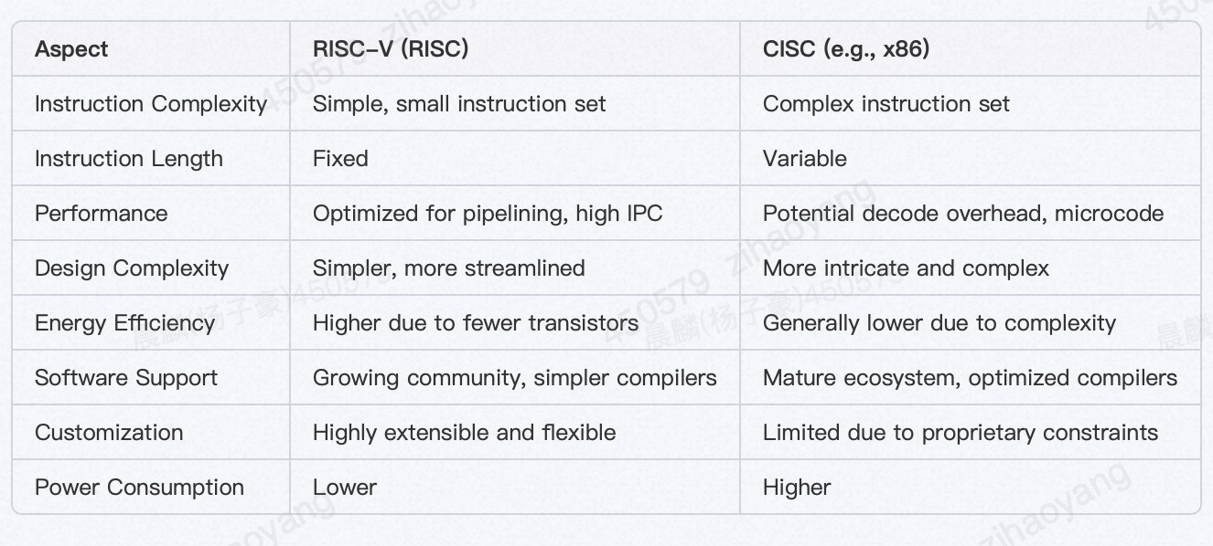

1. Instruction Set Complexity

RISC-V (RISC):

Simplicity: RISC-V employs a smaller, simpler set of instructions. Every instruction is designed to execute in a single machine cycle.

Fixed Instruction Length: Typically, RISC-V instructions are fixed length (e.g., 32 bits), simplifying instruction decoding and pipelining.

Fewer Addressing Modes: RISC-V has fewer and less complex addressing modes, which speeds up the execution and simplifies the CPU design.

CISC (e.g., x86):

Complexity: CISC architectures incorporate a wide array of complex instructions, some of which can execute multiple low-level operations within a single instruction.

Variable Instruction Length: Instructions based by CISC microprocessor architectures are different in length, causing the instruction decode stage complicated and slower.

2. Performance and Efficiency

RISC-V (RISC):

Optimized Pipelining: The simplicity and uniformity of RISC-V instructions optimize pipelining and parallel execution paths, enhancing performance.

Higher Instruction Bandwidth: Due to simpler instructions, RISC-V processors can fetch, decode, and execute instructions faster, potentially resulting in higher instructions per cycle (IPC).

CISC (e.g., x86):

Microcode and Decoding Overhead: Microprocessors based by CISC often use microcode to divide complex instructions into simpler operations. This adds overhead, making each instruction cycle potentially longer.

Lower Instruction Bandwidth: The complexity and variable length of instructions require more time for fetching and decoding, which can reduce overall instruction throughput.

3. Hardware Design and Implementation

RISC-V (RISC):

Design Simplicity: The uniform and simplified instruction set allows for a more streamlined and easier-to-design hardware architecture.

Greater Energy Efficiency: Due to fewer transistors being required for simpler instruction decoding and execution, RISC-V systems tend to be more power-efficient.

CISC (e.g., x86):

Complex Hardware: The wide variety and complexity of instructions necessitate more intricate and elaborate CPU designs.

Higher Power Consumption: More transistors and more complex circuitry typically lead to increased power consumption.

4. Software and Compiler Support

RISC-V (RISC):

Community-Driven Development: RISC-V's open standard nature garners extensive community support, leading to a growing ecosystem of compilers, debuggers, and tools.

Simpler Compilers: The straightforward instruction set leads to simpler, more optimized compiler design and implementation.

CISC (e.g., x86):

Established Ecosystem: x86 has a well-established, mature ecosystem with extensive software support, including highly optimized compilers and a broad range of legacy software.

Compiler Complexity: CISC compilers must handle a diverse set of instructions and optimizations, making them inherently more complex.

5. Customization and Flexibility

RISC-V (RISC):

Extensibility: RISC-V's modular structure allows users to add custom extensions to tailor processors for specific applications without violating the base standard.

Open Standard: Because of being an open standard, RISC-V encourages innovation and customization, RISC-V is suitable for an extensive range of applications from high-performance computer architecture design to embedded systems.

Standardization Across Devices: The x86 architecture has a more rigid, standardized instruction set, offering limited scope for customization.

Proprietary Constraints: Being proprietary, x86 designs are locked down by licensing and intellectual property constraints from a single vendor (e.g., Intel), limiting flexibility.

RISC-V and CISC architectures have distinct advantages and trade-offs. RISC-V's simplicity, power efficiency, and open design make it a strong candidate for modern and future applications, particularly where customization and energy efficiency are critical. On the other hand, CISC architectures like x86 offer mature ecosystems and a well-established base for a wide range of software applications, albeit at the cost of increased complexity and often lower power efficiency. Each has its place depending on the specific needs and constraints of the application in question.

**1.1.3 Types of Instruction Set**

**The base integer instruction set is designed to be minimal and efficient, consistent with the principles of reduced instruction set computing (RISC).**

**RISC-V instruction formats are designed to be straightforward yet flexible enough to cover a wide range of operations. The use of multiple instruction formats enables efficient encoding and execution of different types of instructions, contributing to the overall efficiency and performance of RISC-V-based processors. This design simplicity, combined with the extensibility of the ISA, makes RISC-V a versatile and powerful architecture. The instruction formats are classified into six types: R, I, S, B, U, and J. Each type serves a specific function and has a distinct encoding structure:**

**I-type instructions: I-Type instructions are used for operations involving an immediate value, as well as for load instructions. These instructions include an immediate field that provides a constant value, which is typically used for arithmetic operations, memory accesses, or jumps. Example: lw (Load immediate value).**

**S-type instructions: S-Type instructions are used for storing data from a register into memory. They calculate the memory address using a base register. Example: sw (Store the value in a register to memory).**

**J-type instructions: J-Type instructions are used for unconditional jumps, providing a large immediate offset for the jump target. Example: j (Jump).**

**B-type instructions: B-Type instructions are used for conditional branching. They compare two registers and change the control flow based on the result of the comparison. Example: beq (Compare and branch if equal).**

**R-type instructions: R-Type instructions are used for performing arithmetic and logical operations where both operands are registers. These instructions typically execute in a single cycle and are fundamental to computational tasks in the CPU. Example: add (Add two registers and store the result in another).**

**Each instruction type and example mentioned illustrates the versatility and efficiency of the RISC-V base integer instruction set.**

Instruction Set Architectures (ISAs) are foundational standards that dictate how a processor's hardware should operate and how it interacts with its corresponding assembly language [3]. These standards encapsulate the necessary details to build a processor capable of executing machine code reliably the defined specifications [2]. This involves information covering instructions, data buses registers, memory access, arithmetic operations, and more. Although the standard specifies every function of the processor, the implementation details of the hardware and circuits are tested the designer's discretion. ISAs usually include various variants for meeting needs of diverse design requirements. These can range from extensions supporting multiplication and floating-point calculations to different address, data, and instruction widths, catering to embedded systems, personal computers, supercomputers, and other applications [4].

The openness of RISC-V makes it ideal for projects seeking to develop open-source CPUs, avoiding the limitations of the more simplified academic ISAs, and rather than employing a more useful and applicatory approach. Despite existing open-source RISC-V processor implementations, there is a gap for solutions that are both straightforward and intuitive enough for beginners to follow.

In this paper, I present a lightweight implementation of a microprocessor based on RISC-V instruction, crafted using contemporary hardware design techniques and deployed on a Field Programmable Gate Array for testing. The goal was to develop a microprocessor based on RISC-V which is sufficiently simple for implementing on little-scale FPGAs.

**1.2 Literature Review**

**1.2.1 Hard-Core Implementation vs Soft-Core Implementation**

Soft Core Implementation

A soft core is a processor core that is implemented using a hardware description language (HDL) such as Verilog or VHDL. These cores are intended to be synthesized onto reprogrammable logic devices like FPGAs (Field Programmable Gate Arrays) or synthesized into ASICs (Application-Specific Integrated Circuits).

Advantages of Soft Core:

1. Flexibility and Customization:

Customization: Easily modified to meet specific application requirements, enabling custom instruction sets and tailored configurations.

Adaptability: Soft cores can be adjusted to fit various FPGA sizes and capabilities.

1. Rapid Prototyping:

Development Speed: Allows rapid prototyping and testing, which is particularly useful in the early stages of product development.

Iterative Design: Changes can be quickly compiled and tested, accelerating the development cycle.

1. Lower Initial Cost:

FPGA Usage: Deployment on FPGAs can reduce initial costs compared to designing and fabricating custom silicon.

1. Educational and Research Use:

Experimental Flexibility: Ideal for academic research and teaching, providing a platform for experimenting with new architectures and optimizations.

Disadvantages of Soft Core:

Performance:

Lower Speed: Soft cores typically do not achieve the same performance levels as hard cores due to limitations in FPGA speed and efficiency.

Latency: May have higher latency due to the FPGA's less optimized routing and logic implementation compared to ASICs.

Power Consumption:

Higher Consumption: Generally, higher power consumption compared to hard cores, which is critical for battery-powered or high-performance applications.

Size Constraints:

FPGA Limits: Limited by the capacity of the FPGA, which may restrict the complexity and number of cores that can be implemented.

Rocket Core: Developed by the Berkeley Architecture Research group, used widely in academic and industry projects.

PicoRV32: A minimalistic, 32-bit soft core processor for small to medium FPGA implementations.

Hard Core Implementation

A hard core is a processor core that is physically implemented as part of a silicon die, either as part of an ASIC or a SoC (System on Chip).

Advantages of Hard Core:

Performance:

Higher Speed: Offers higher clock speeds and better overall performance due to custom silicon optimizations.

Efficiency: Optimized for speed, power, and size, making them suitable for performance-critical applications.

Power Efficiency:

Lower Power Consumption: Typically more power-efficient as the design is optimized at the transistor level.

Thermal Management: Better thermal performance due to optimized silicon layout.

Integration:

Compact Design: Hard cores can be tightly integrated with other system components on the same chip, reducing overall system size and complexity.

Optimized Routing: Easier to plan and optimize the interconnections between multiple cores and other on-chip peripherals.

Disadvantages of Hard Core:

Cost:

High Upfront Cost: High non-recurring engineering (NRE) costs associated with designing and fabricating custom silicon.

Manufacturing Costs: More expensive to iterate and update compared to FPGAs, which can negatively impact the development cycle.

Flexibility:

Less Customizable: Once fabricated, hard cores lack the flexibility for customization, making it difficult to modify for different applications.

Longer Development Time: Designing, fabricating, and testing custom ASICs or SoCs is more time-consuming compared to deploying on FPGAs.

SiFive Processors: SiFive offers a range of commercial RISC-V processors, including both soft and hard cores. The "U-Series" processors, for example, are targeted at applications requiring high performance.

Nvidia Jetson: Integrates RISC-V hard cores for certain control functions within its larger ARM-based SoC.

The choice between a RISC-V soft core and a hard core depends on the specific needs and constraints of the application. Soft cores offer flexibility, lower initial costs, and are ideal for prototyping and education, while hard cores provide higher performance, efficiency, and are better suited for mass production and performance-critical applications. Both implementations are vital to the growing adoption and versatility of the RISC-V architecture, providing options that cater to a wide spectrum of requirements from research to commercial deployment.

**1.2.2 RISC-V Instruction Set Microprocessor Architecture**

The RISC-V instruction set processor adopts a typical RISC microarchitecture, characterized by in-order fetch, out-of-order execution, and in-order completion. The microprocessor architecture includes five pipeline stages: Instruction Fetch, Instruction Decode, Register Select (RS), Execute (EXE), and Write Back (WB). **Figure 2** provides an overview of the architecture of this 5-stage pipelined processor.

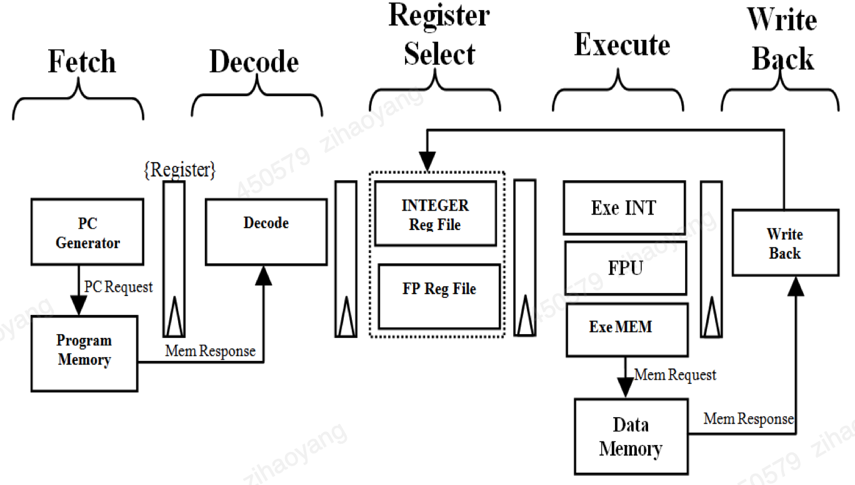 **Figure 2: Top level architecture of RISC-V Processor**

**Detailed Pipeline Stages:**

**A. Fetch Stage**

Figure 3 depicts the microarchitecture of the fetch unit. The fetch unit computes the current PC and predicts the next PC value. It includes a 32-bit register for storing the current PC value and a 32-bit adder to compute the next PC by incrementing the current PC by 4. The next PC can either be PC+4 through utilizing branch prediction technology [4][5].

Branch prediction includes a Branch Prediction unit and a Branch Target Buffer. The Branch Target Buffer unit produces a Boolean valid signal along with the relative target PC address, while the branch prediction unit provides Boolean information indicating whether the PC value is present or not. The next PC value is decided by predicted PC or PC+4 based on the prediction and valid signals. The current PC and next PC values are then passed on to the Decode stage for further processing. Notably, in this paper, branch prediction is omitted since there are very few branch instructions in the project.

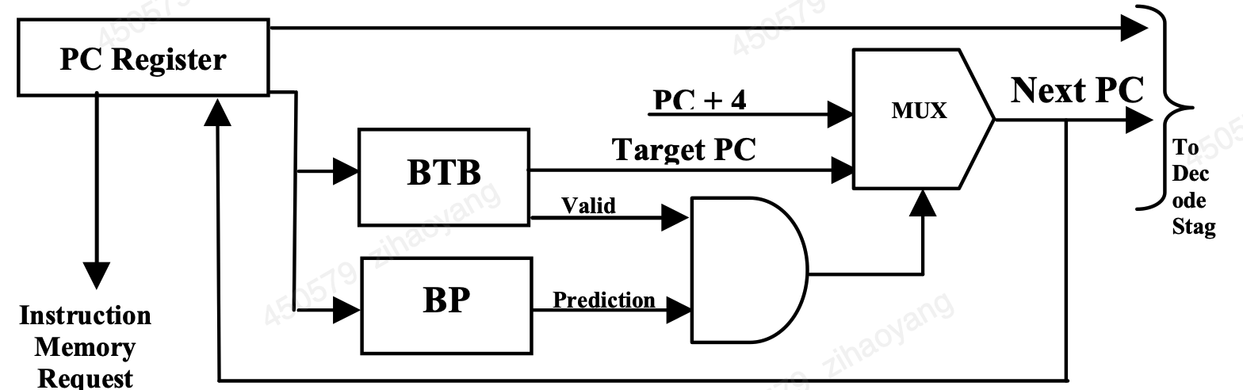

**Figure 3: Micro Architecture of Fetch Unit**

#### B. Decode Stage

In the Decode stage, the instructions from ROM are transferred to the instruction decoder module with the prediction and corresponding PC value from the IF stage. Based on the lower 7 bits of each instruction (the opcode), instructions are classified as per Table 1. Subgroup information is decoded from a 3-bit field known as the function field. Each instruction type has fixed positions for the source and destination registers, which are 5 bits each. Immediate type instructions have their immediate data sign-extended to 32 bits for further processing. For simplicity and to conserve FPGA resources, this paper simplifies the opcode to 8 bits, as there are not many types of instructions requiring a full 32 bits.

The decoder generates control signals necessary for subsequent instruction processing, including Register Update, Register Access, and pipeline information, indicating on which pipeline the instruction is scheduled.

#### C. Register Select Stage

The Register Select (RS) stage receives the information decoded from the Decode stage and then selects the integer or floating-point operand register file which can be implemented as a RAM. The integer register file includes 32 registers, each 32 bits wide, while the floating-point register file has 32 registers, each 64 bits wide. Both register files have three read ports and one write port, with a latency of one clock cycle.

**Figure 4** shows the organization of the register file for the RISC-V processor. The unit accepts three source address inputs (Rd_Addr_1, Rd_Addr_2, Rd_Addr_3) and a control signal (Reg_Access), specifying whether the access is for the integer or floating-point register file. The output is a 64-bit data line from the appropriate register file, and there is one 64-bit write port for write-back operations. According to the pipeline information from the Decode stage, operands are routed either to the integer ALU/memory address computation pipeline or the FP execution pipeline. An instruction scheduler FIFO, part of the integer/memory/FPU execute stage, is used to manage instruction scheduling and ensure in-order commitment.

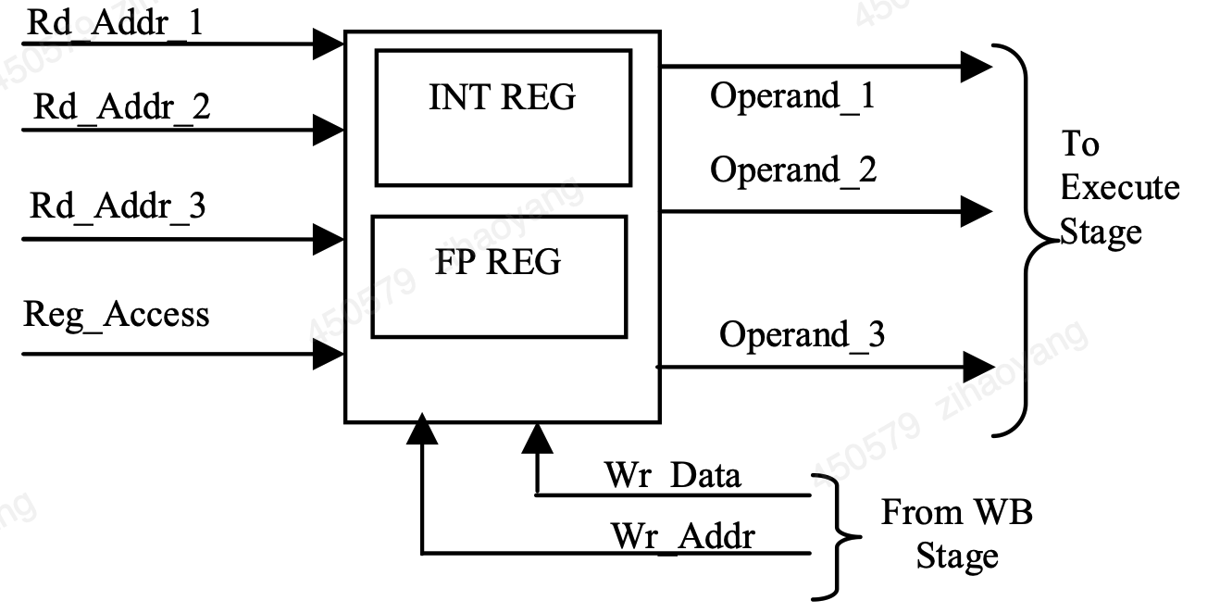

**Figure 4: Register File Organization**

#### D. Execute Stage

The Execute stage includes following three concurrent units:

1. **Integer Execution Pipeline:** Handles arithmetic operations (addition, subtraction, multiplication, and division) and logical operations (AND, OR, XOR, and shift). It also computes target addresses for jump and branch instructions. The integer unit executes system-related instructions such as SCALL and SBREAK for supervisor-level access. An efficient data forwarding scheme forwards the output of execution units to their inputs, as detailed in section VI.
2. **Memory Pipeline:** Calculates target memory addresses for sw store and lw load operations. The RISC-V ISA supports sw store and lw load operations on bytes, half-words, and words.
3. **Floating-Point Execution Pipeline:** Handles floating-point arithmetic operations. The microarchitecture of the out-of-order FP execution unit is detailed.

#### E. Write Back Stage

The Write Back (WB) stage is responsible for committing instructions from the pipeline and utilizing calculated result from execute unit to update the register file. Based on the pipeline information, WB reads the instruction from the top of the scheduled instruction and reads the results from either the integer, memory, or floating-point units to commit the instructions in the correct order.

By detailing each stage and expanding on specific elements such as the branch prediction scheme, instruction decoding, and register file organization, this revised text provides a thorough understanding of the RISC-V processor's architecture while maintaining the original intent and information.

**1.2.3 Harvard and Von Neumann Architecture**

Harvard Architecture

A Harvard architecture microprocessor is a type of computer architecture that distinguishes itself by its separate storage and signal pathways for instructions and data. In contrast to the von Neumann architecture, where program instructions and data share the same memory space and pathways, the Harvard architecture uses distinct memory regions and communication channels. This separation allows for concurrent access to instructions and data, potentially increasing processing speed and efficiency.

Key Features of Harvard Architecture:

1, Separate Memory Units: The most prominent feature is the use of separate memory spaces for instructions and data. This can reduce memory bottlenecks by allowing simultaneous access to instruction and data memories.

2, Dedicated Buses: The architecture typically employs separate buses for instruction fetches and data reads/writes, enabling parallel processing of these tasks.

3, Efficiency and Speed: Harvard architecture can achieve higher throughput since instructions can be fetched while data is being read or written. This is particularly advantageous in real-time and embedded systems.

4, Simplicity in Design: This architecture can simplify certain aspects of the microprocessor design because instruction fetches are predictable and do not interfere with data operations.

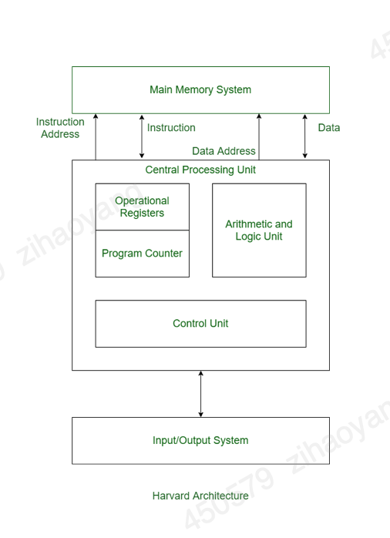

**Figure 5: Harvard Architecture**

Von Neumann Architecture

**Von Neumann Architecture** is a fundamental computer architecture model that uses a single memory space for both instructions and data, allowing program instructions and data to reside in the same memory module and share the same address space.

Characteristics:

1. **Unified Memory:**
   * Uses the same memory space for both instructions (program code) and data.
2. **Sequential Execution:**
   * Instructions are executed sequentially as fetched from memory unless explicitly modified by control flow instructions like branches or jumps.
3. **Single Bus System:**
   * Employs a single set of buses for data transfers and instruction fetches, leading to a potential for bottlenecks.
4. **Control Unit (CU):**
   * Manages the sequential execution of instructions, including fetching instructions from memory, decoding them, and orchestrating the flow of data within the CPU.
5. **Arithmetic Logic Unit (ALU):**
   * Performs arithmetic operations (such as addition and subtraction) and logical operations (such as AND, OR, and NOT).
6. **Registers:**
   * Small, fast storage locations within the CPU used to hold data temporarily during processing.
7. **Fetch-Decode-Execute Cycle:**
   * The operation of fetching an instruction from memory, decoding it to understand the required operation, executing the operation, and then fetching the next instruction.
8. **Single Memory Interface:**
   * Uses a single memory interface for both instruction fetches and data transfers. This is often viewed as a limiting factor for performance.

Advantages:

1. **Simplicity:**
   * The design and implementation of the von Neumann architecture are simpler because it uses a unified memory system and a single set of buses. This can lead to easier programming and understanding.
2. **Flexibility:**
   * With instructions and data stored in the same memory, the architecture allows for a more flexible use of memory. Programmers can easily change or modify stored program instructions and data.
3. **Cost-Effective:**
   * Requires fewer hardware components and resources than architectures with separate memories and buses, making it less expensive to implement.
4. **General-Purpose Application:**
   * Suitable for a wide range of applications, particularly general-purpose computing, where complex procedures and varied computations are required.

Disadvantages:

1. **Von Neumann Bottleneck:**
   * The primary disadvantage is the potential for a bottleneck, where the single bus must handle both data and instruction fetches. This can slow down the processing speed since the CPU might have to wait for data while fetching instructions or vice versa.
2. **Memory Access Conflict:**
   * The unified memory system means that instruction fetches and data transfers cannot happen simultaneously, leading to contention and reduced overall efficiency.
3. **Latency:**
   * Increased latency in memory access due to the need to switch between instruction fetching and data accessing, which can hamper the overall speed of execution.
4. **Potential Security Issues:**
   * Since programs and data share the same memory space, it may be easier for malicious code to exploit this shared space, leading to potential security vulnerabilities.

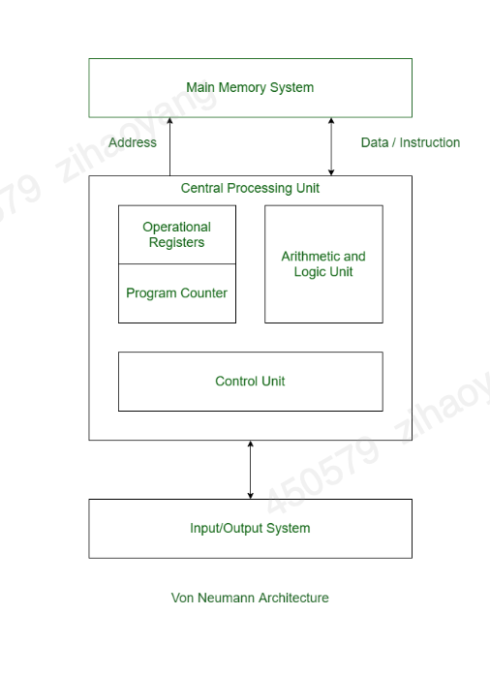

Figure 6: Von Neumann Architecture

**Comparison of Von Neumann and Harvard Architectures**

Von Neumann and Harvard architectures are fundamental models for the design of computer systems, each with distinct characteristics, benefits, and limitations. Below is a detailed comparison of the two architectures:

Memory Architecture:

**Von Neumann Architecture:**

* **Unified Memory**: Uses a single memory space shared for both instructions (program code) and data. This means that both the program instructions and the data reside in the same memory.
* **Single Bus**: Employs a single bus for data transfers and instruction fetches, leading to potential bottlenecks.

**Harvard Architecture:**

* **Separate Memory**: Distinguishes between instruction memory and data memory, with separate storage and pathways for each.
* **Separate Buses**: Uses separate buses for instruction fetch and data transfer, allowing concurrent access to instructions and data.

Advantages:

**Von Neumann Architecture:**

* **Simplicity**: Easier to design and implement due to a unified memory system and a single set of buses.
* **Flexibility**: Can use the same memory space dynamically for both code and data, which can be more flexible in certain applications.
* **Cost-Effective**: Typically requires less hardware due to the unified memory and bus system.

**Harvard Architecture:**

* **Speed**: Can achieve higher performance by allowing concurrent access to instructions and data, making use of separate pathways.
* **Parallelism**: Reduces contention and potential bottlenecks in memory access, which can significantly boost execution speed.
* **Security**: The separation of instruction and data memory can provide an extra layer of security, preventing certain types of attacks.

**Disadvantages:**

**Von Neumann Architecture:**

* **Bottleneck**: The single bus structure can lead to a bottleneck, where the CPU has to wait for memory access, leading to inefficiencies.
* **Contention**: Concurrent access to memory for instructions and data is not possible, which limits parallelism.

**Harvard Architecture:**

* **Complexity**: More complex to design and implement due to separate memory spaces and buses.
* **Flexibility**: Less flexible in terms of dynamic memory allocation since the instruction and data memories are separate.
* **Cost**: Potentially more expensive due to the additional hardware required for separate memory and bus systems.

Use Cases:

**Von Neumann Architecture:**

* **General-Purpose Computing**: Well-suited for general-purpose computers and environments where program instructions and data can be effectively managed within a unified memory system.
* **Low-Cost Systems**: Preferred in cost-sensitive applications where the simplicity and reduced hardware costs are paramount.

**Harvard Architecture:**

* **Real-Time Systems**: Ideal for digital signal processing (DSP) and real-time embedded systems where high throughput and predictable performance are essential.
* **Microcontrollers**: Often used in microcontrollers and other embedded systems requiring efficient and high-speed operations.

Both von Neumann and Harvard architectures offer unique advantages and are suited to different types of applications. The von Neumann architecture is praised for its simplicity and flexibility, making it a cost-effective solution for many general-purpose computing tasks. However, it can suffer from performance bottlenecks due to its unified memory and single bus system. In contrast, the Harvard architecture excels in scenarios demanding high throughput and real-time performance, such as DSPs and embedded systems. Its separation of instruction and data memory reduces contention and allows for concurrent operations, thereby boosting speed and efficiency. However, it comes with increased complexity and potentially higher costs.

Understanding these architectures' strengths and limitations is crucial for selecting the appropriate computational model for specific applications, optimizing for performance, cost, and design complexity. Therefore, we choose Harvard architecture in this project.

**1.2.4 Logical and Arithmetic Unit**

A combinational circuit is essential in performing arithmetic and bitwise operations on integer binary values. It plays a critical role in various computing circuits. The arithmetic functions include both addition and subtraction. For data comparison, relational operations such as less than, not equal to, greater than or equal to, greater than, and equal to are utilized to evaluate different conditions. Examples of shifting operations include rotate right, rotate left, right shift, and left shift. Additionally, logical functions such as XOR, AND, and OR are performed by the circuit [16].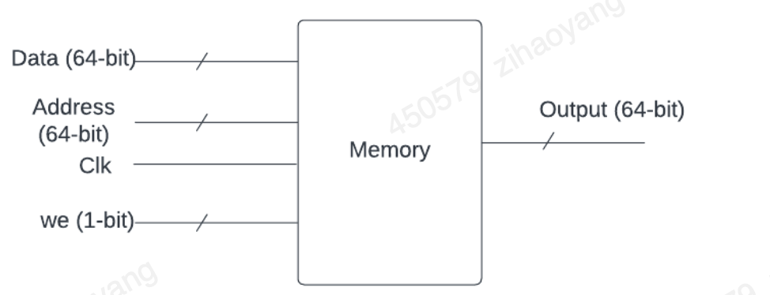

Figure 7: ALU diagram

The ALU (Arithmetic Logic Unit) can perform a variety of operations based on relative inputs and export the output [17]. My designed ALU supports eight distinct operations: subtraction, addition, logical AND, division, logical OR, logical left shift, and logical right shift. The specific operation executed is decided by operation signals from the microprocessor, which are based on the type of instruction being processed. Normally, executing calculation instruction like add, sub are the major ALU usage, but and logical instructions such as AND and OR also needed. Additionally, it is also required for addressing calculations performed during write, read, and BREQ (branch if equal) instructions.

Implementing a 32-bit fixed-point division algorithm on an FPGA involves careful handling of integer and fractional parts of the numbers, as well as precision management. A popular method for fixed-point division is the Restoring Division Algorithm, which is iterative and suitable for hardware implementation.

Here's a simplified step-by-step approach of Restoring Division Algorithm:

1. Initialization:
   * Set up the numerator and denominator in the Q16.16 fixed-point format.
   * Initialize the quotient and remainder registers.
   * Align the remainder with the numerator.
2. Iterative Subtraction:
   * For each bit of the quotient, shift the remainder left by one bit and subtract the adjusted denominator.
   * If the result is non-negative, set the quotient bit to 1, and keep the remainder.
   * If the result is negative, reset the quotient bit to 0, and restore the remainder.
3. Final Adjustment:
   * After all bits are processed, shift the result to adjust for the fixed-point format and obtain the final quotient.

Implementing a 32-bit fixed-point division on FPGA using the restoring division algorithm involves setting up registers for extended precision, iterating through bit-by-bit comparisons and subtractions, and managing the state transitions to control the division process. This Verilog module provides a clear and functional template for developing fixed-point arithmetic operations on FPGA, demonstrating the precision and control required for efficient digital computation. Further optimization can be applied based on the specific FPGA architecture and application requirements.

A portion of the data memory is read-only upon startup, which is advantageous since the limited instruction set does not offer immediate instructions. This memory area can be flashed using a “.mem” file, similar to the instruction memory. The Write and Read instructions handle memory-related operations—Write takes a value from a specified memory address and stores them in register, while Read retrieves data from a register and stores it in the memory.

|  |  |
| --- | --- |
| **Instruction** | **Description** |
| Write | Write value from register to memory |
| Read | Read value from memory to register |
| Add A, B, Out | Addition |
| Sub A, B, Out | Subtraction |
| Multi A, B, Out | Multiplication |
| Divide A, B, Out | Division |
| Left Shift | Bit Operation left shift |
| Right Shift | Bit Operation right shift |
| And | Bitwise And operation |
| Or | Bitwise Or operation |
| BREQ | if register A’s stored value is equal to Register B’s stored value then load PC with address to realize Branch to |
| BGTQ | if register A’s stored value is greater than Register B’s stored value then load PC with address to realize Branch to |
| BLTQ | if register A’s stored value is less than Register B’s stored value then load PC with address to realize Branch to |
| Jump | Directly branch to address where PC is |

Table 1

#### Memory Instructions

**Write and Read** are fundamental memory-related instructions.

* **Write Instruction**: This instruction takes a value from a specified memory address and stores it into a register. Essentially, it moves data from memory to a register.
* **Read Instruction**: Conversely, the Read instruction transfers data from a register and stores it at a designated RAM address. This functionality facilitates storing computation results or other necessary data back into memory for later use.

#### Arithmetic Instructions

**Add and Sub** are essential arithmetic instructions used in computations:

* **Add Instruction**: The Add instruction extracts the values of two sources registers, executes unsigned addition, and stores the result at the targeted register. If the sum exceeds the range of an integer, the output wraps two’s complement representation, where negative numbers are handled seamlessly.
* **Sub Instruction**: The Sub instruction subtracts the contents of one source register from another and saves the result in the targeted register. Similar to the Add instruction, if the result of the subtraction exceeds the representable range, it wraps around using two’s complement representation.

Digital Multipliers

In digital electronics, multipliers are circuits used for multiplying binary numbers. The **Baugh-Wooley signed multiplier** is particularly suitable for our micro-architecture due to its low power consumption and efficient handling of signed numbers in two’s complement form. Notable for its cost-effectiveness, the Baugh-Wooley multiplication method is adept at dealing with sign bits.

**Baugh-Wooley Multiplier**: This signed multiplier circuit has a delay of 5.97 nanoseconds. If used directly in the Immediate Execute (IE) stage, it would significantly lengthen the critical path of the system. Hence, the hardware implementation of this multiplier is divided into two stages to optimize performance.

**First Stage**: This stage calculates partially computed products, which are then divided into six components and summed together. The resulting sum is buffered, preparing it for the next stage.

**Second Stage**: In this stage, the six buffered intermediate results are summed once more to obtain the final multiplication result. This division into stages keeps the delay of the first stage lower than that of the second stage, optimizing the overall operation sequence.

The complete multiplier setup includes 29 Full Adders (FAs) and 1 Half Adder (HA) in the critical path of the first stage. Inputs to the multiplier may come from the register bank or various pipeline stages, necessitating a multiplexer to manage input delays efficiently.

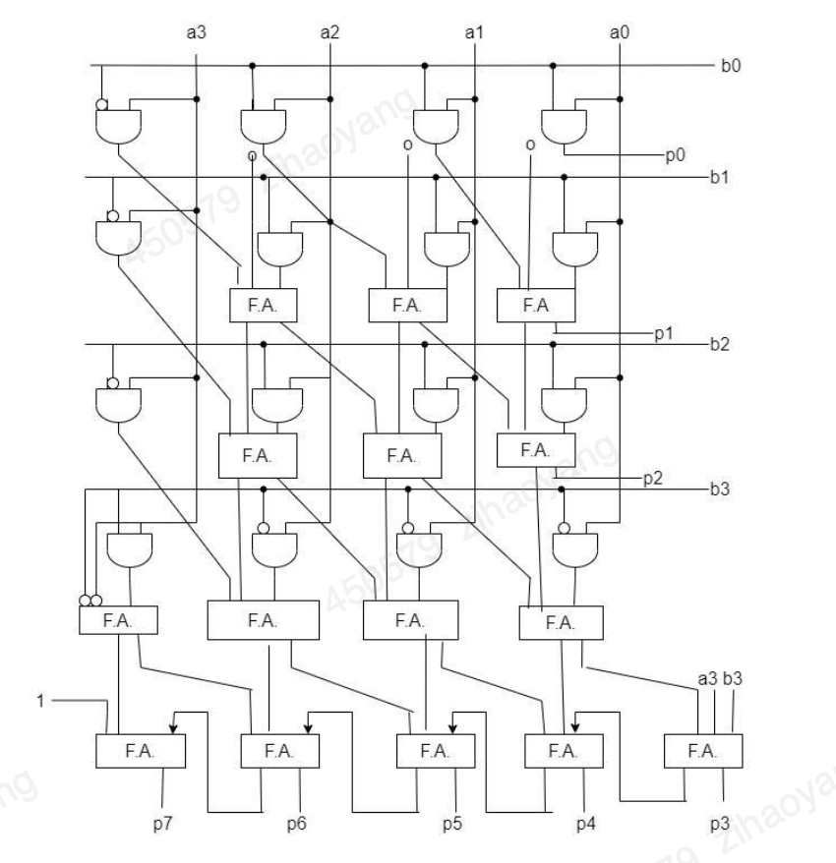

Figure 8 Multiplier block diagram

Logical Instructions

**‘OR’** **and ‘And’** are two basic yet crucial logical instructions type among the instruction set:

* **AND Instruction**: This instruction retrieves the values of two source targeted registers, executes the bitwise AND operation between them, and saves the resulting value in the targeted register.
* **OR Instruction**: Similarly, the OR instruction takes the contents of two source registers, performs a bitwise OR operation, and saves the result in a destination register.

Shifter Unit

A **shifter** is a vital digital circuit that can rearrange the bits in a data word. It has the capability to shift N-bit data either to the left or right within a single cycle. Shifters are multifaceted, performing various types of shifts and rotations, including arithmetic shifts, logical shifts, and rotations.

Functionality of Shifters:

* **Arithmetic Shifting**: This operation shifts bits while preserving the sign of the binary number.
* **Logical Shifting**: This type of shift moves bits while filling the vacated positions with zeros.
* **Rotation**: This function rotates bits such that the bits shifted out on one end are reintroduced at the other end.

Implementation Details:

An N-bit shifter can be constructed using N N:1 multiplexers. This allows the input to be shifted by 0 to N-1 bits, depending on the value of the log₂N-bit select lines. Shifters are indispensable for manipulating bits in the partial products of multiplication and division processes, as they can effectively multiply or divide numbers by powers of two.

The **logical instructions** AND and OR facilitate essential bitwise operations that modify data based on logical criteria, contributing to the flexibility and capability of the instruction set. Meanwhile, **shifters** serve a crucial role in adjusting the order of bits for various operations, enabling effective arithmetic computations with their ability to shift and rotate bits efficiently. Together, these components play a significant role in the operational efficiency and versatility of the processor's architecture.

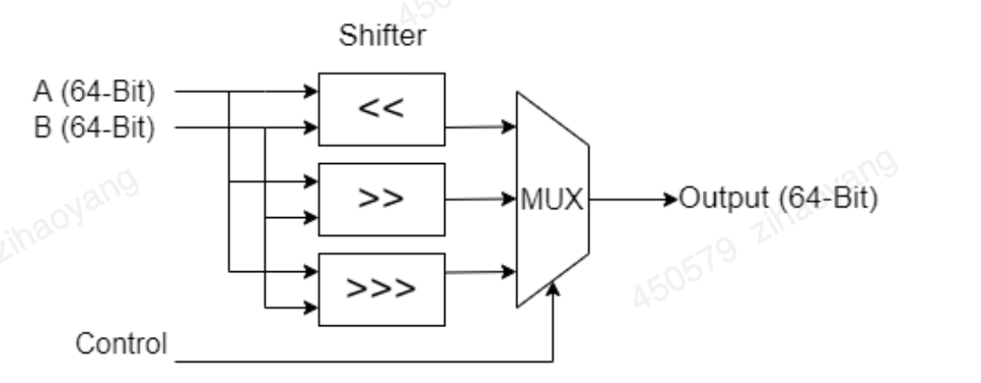

Figure 9: Shift diagram

Branch instructions in the RISC-V architecture are critical for altering the normal sequential flow of program execution based on specific conditions. Here, we focus on three types of conditional branch instructions: BREQ, BGTQ, and BLTQ [7].

#### BREQ (Branch if Equal)

The **BREQ** instruction stands for "branch if equal." This instruction compares the contents of two source registers by computing their difference. If the result is zero, indicating that the registers hold identical values, the program counter (PC) is adjusted by the BREQ instruction. This causes the program to jump to a new location. In the absence of a branch, the PC increments sequentially with each clock cycle. However, when the BREQ condition is met, the PC can either move forward or backward, depending on the offset, effectively altering the program's flow based on the equality of the two registers.

#### BGTQ (Branch if Greater Than)

The **BGTQ** instruction, or "branch if A is greater than B," evaluates whether the value in register A is greater than the value in register B. It does this by subtracting the contents of register B from register A. If the result is positive, indicating that register A's value exceeds that of register B, the program counter is modified by the signed offset provided by the BGTQ instruction. This branching mechanism allows for conditional jumps within the program, enabling the PC to jump ahead or fall back by a specified number of instructions based on the comparison outcome.

#### BLTQ (Branch if Less Than)

The **BLTQ** instruction stands for "branch if register A is less than register B." Similar to BGTQ, this instruction subtracts the contents of register B from register A. If the result is negative, indicating that register A's value is smaller than register B's value, the program counter is adjusted by the BLTQ instruction. This allows the program to jump to a new instruction, either forwards or backwards, based on whether register A is less than register B. Like the other branch instructions, BLTQ facilitates conditional changes in program execution, circumventing the default sequential progression of the PC.

In summary, these conditional branch instructions—BREQ, BGTQ, and BLTQ—allow the program counter to jump to new locations based on specific conditions derived from register comparisons. This capability is pivotal for implementing control flows such as loops and conditional statements, thereby enhancing the flexibility and functionality of the RISC-V processor.

### 1.2.5 State Machine

A state machine, also known as a finite state machine (FSM), is a computational model used to design systems that can be in one of a finite number of states at any given time. State machines are widely employed in various fields of engineering, particularly in digital design, control systems, and computer science, to model the behavior of both hardware and software systems.

The fundamental concept of a state machine revolves around the idea that a system's behavior can be described in terms of states, transitions, and actions. Each state represents a unique configuration of the system, and transitions are the conditions under which the system moves from one state to another. Actions are the tasks or operations performed while entering, exiting, or dwelling in a particular state.

State registers and combinational logic circuits are two components of state machine. State machines are divided into Moore state machines and Mealy state machines. Moore state machine can transfer states according to pre-set states based on control signals while Meely state machine needs transfer pre-set state and input to decide the next state.

A state is a distinct mode or condition in which a system can exist. It embodies specific characteristics or functionalities of the system at a particular moment.

Each state is typically represented by a unique label or identifier, such as S0, S1, Idle, or Active.

Transitions define how the system moves from one state to another based on certain conditions or events.

A transition is usually triggered by inputs, signals, or internal events, which are explicitly defined as part of the system's behavior.

Events are occurrences that can cause state transitions. They can be external inputs (like a button press) or internal events (like a timer expiration).

Inputs are external signals or data that influence the state machine's transitions and actions. Outputs are the signals or data produced by the state machine based on the current state and input events.

Actions are operations performed as a result of entering, exiting, or being in a particular state. These actions can include generating outputs, invoking procedures, or modifying data. State machines provide a structured and systematic way to design complex systems with predictable behavior. By breaking down the system into states, transitions, and actions, designers can create efficient, manageable, and reliable solutions for both hardware and software applications.

Designing a state machine involves several steps:

1, Define States and Events:

Identify and label all the possible states of the system.

Determine the events or conditions that can cause state transitions.

Create a State Transition Diagram:

2, Draw a visual representation of states and transitions, often in the form of a state transition diagram or finite state machine diagram.

Indicate events that trigger transitions and actions performed during these transitions.

3, Implement the State Machine:

Translate the state transition diagram into a formal implementation using hardware description languages (for digital circuits) or programming languages (for software-based systems).

Ensure that each state, transition, and action is accurately represented in the implementation.

4, Test and Validate:

Thoroughly test the state machine to ensure it behaves correctly under all possible conditions and transitions.

Validate the design by simulating inputs and verifying outputs and state changes.

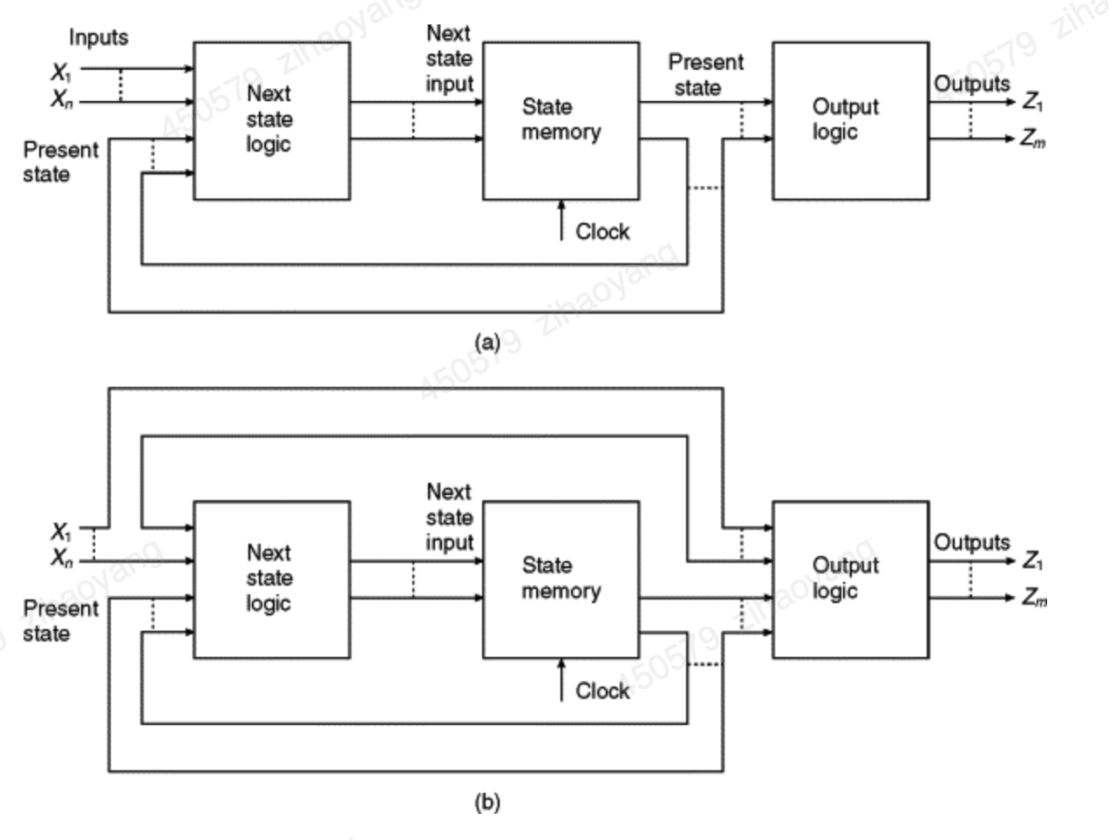

Figure 10: Moore vs Mealy State Machine

# 2. Digital system Design

**2.1 Microprocessor-based System for Remote Car Control**

The following figure gives a block diagram of the overall Digital system implemented on FPGA for realizing the remote car control application. The microprocessor is the core module as master compared with various other modules regarded as slaves. And the master and slaves are communicated through 8-bits Data Bus and Address Bus

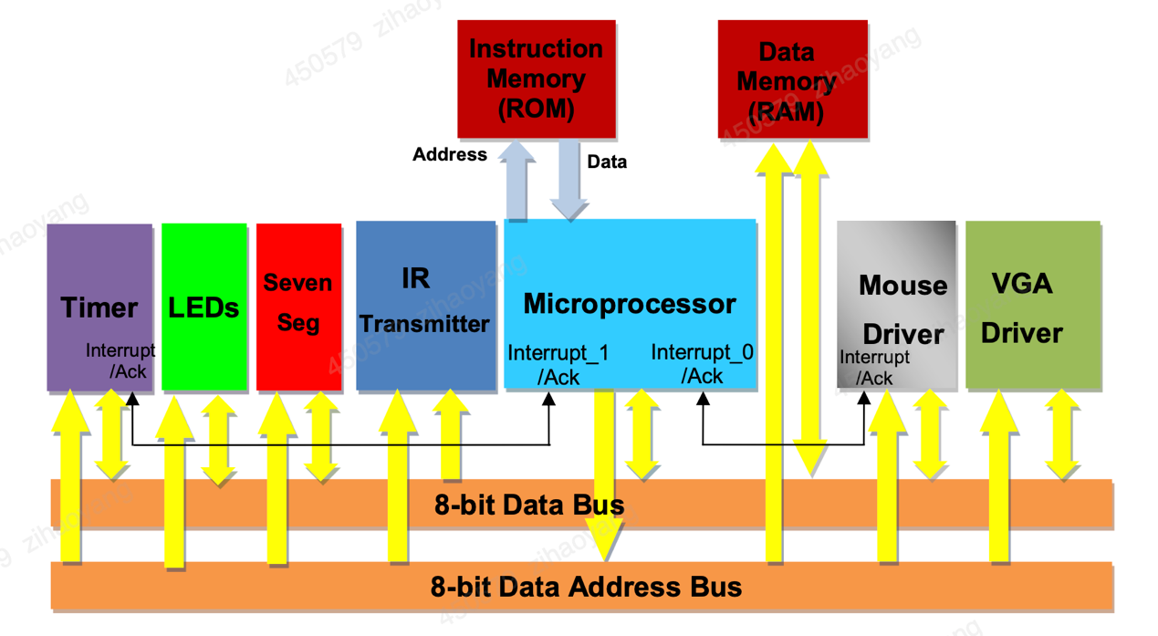

Figure 11: Overall Digital system block diagram

The following table states the memory mapping of the modules on the microprocessor’s data address bus.

|  |  |  |
| --- | --- | --- |
| **Modules** | **Base Address** | **High Address** |
| IR Transmitter | 0x90 | 0x90 |
| Mouse | 0xA0 | 0xA2 |
| VGA Display | 0xB0 | 0xB2 |
| LEDs | 0xC0 | 0xC0 |
| SevenSeg | 0xD0 | 0xD1 |
| Timer | 0xF0 | 0xF3 |
| Data Memeory | 0x00 | 0x7F |

**Table 2**

Note that the proposed microprocessor has a Harvard architecture which means that the instruction memory and data memory are distinct with separate address and data busses for each of them. Parallel accesses to both instructions and program data can thus be made, resulting in higher performance compared to Von-Neumann processors where instructions and data are stored on the same memory.

The microprocessor I've designed is an 8-bit system utilizing a load-store architecture, featuring two internal registers, A and B, for holding operands and operation results [18]. At the heart of the processor is an Arithmetic and Logic Unit (ALU) capable of executing a variety of operations:

* Addition of operands A and B
* Subtraction of operands A and B
* Multiplication of operands A and B
* Left shift of operand A by one bit
* Right shift of operand A by one bit
* Incremental increase of operand A
* Incremental increase of operand B
* Decremental decrease of operand A
* Decremental decrease of operand B
* Equality check between operands A and B, outputting 0x01 if true, else 0x00
* Greater than comparison (A > B), outputting 0x01 if true, else 0x00
* Less than comparison (A < B), outputting 0x01 if true, else 0x00

The specific operation performed by the ALU is determined by a 4-bit operation code (opcode) as illustrated in Figure 12.

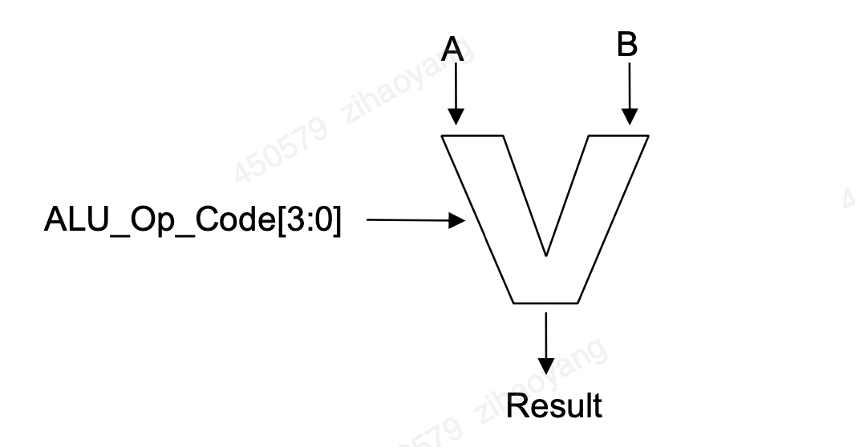

**Figure 12:**

Verilog code to implement the above ALU is given to you below.

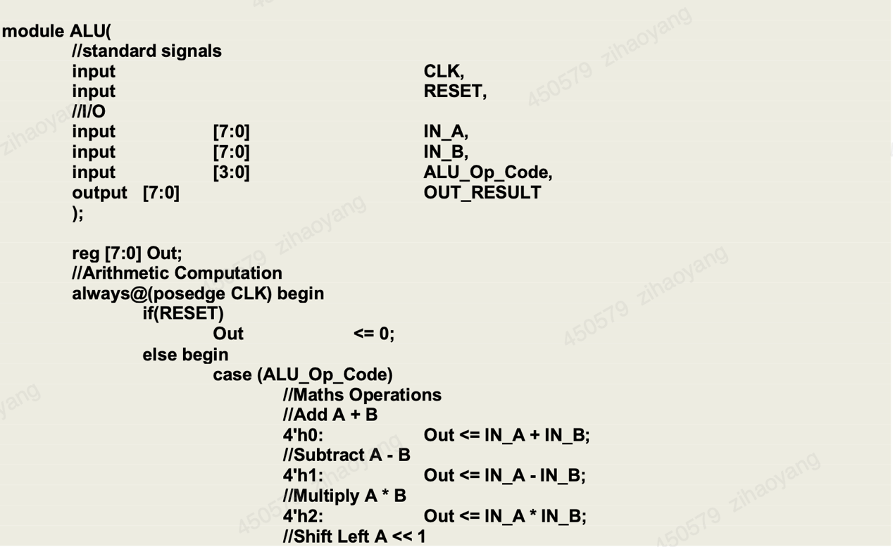

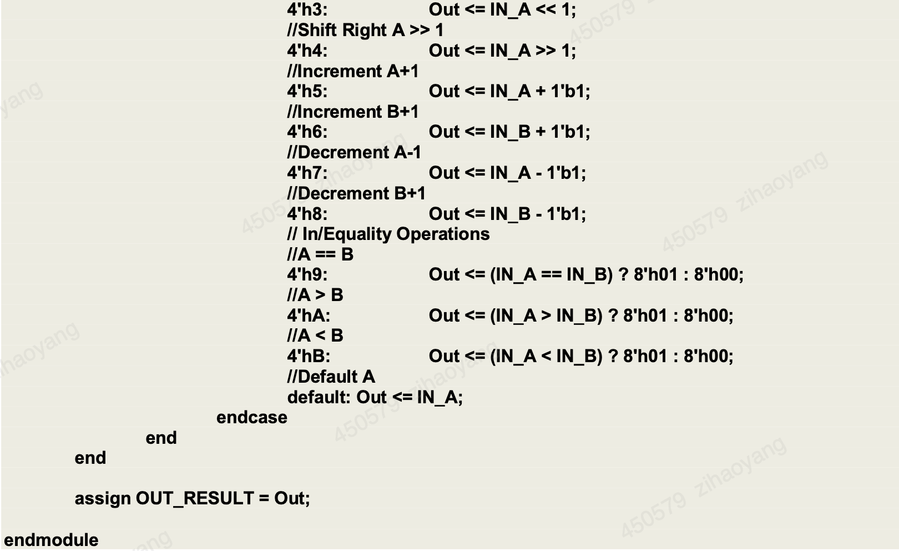

Fixed-Point Division ALU Design

The non-restoring division algorithm is one of the simpler methods used for division. Here's a brief outline:

1. Initialization:

Load the dividend and divisor.

Set the remainder to 0.

1. Iterative Process:

Perform a trial subtraction of the divisor from the current remainder.

Based on the result of the subtraction:

If the result is positive or zero, set the corresponding quotient bit to 1.

If the result is negative, restore the previous remainder and set the corresponding quotient bit to 0.

Shift the remainder to the left and bring down the next bit of the dividend.

Continue for the number of bits in the dividend.

1. Final Adjustment:

After all bits are processed, if the remainder is negative, add the divisor back to the remainder [20].

Here is the simulation result by written testbench in Vivado where a represents dividend and b represents divisor.



The microprocessor has 6 types of instructions overall:

1. Read from memory to Register A or B
2. Write to memory from Register A or B
3. Do an ALU operation and save the result in register A or B
4. Jump operations: *conditional jump* depending on whether register A’s content is equal, greater than or less than register B’s content, or *unconditional jump* to a particular address.
5. Function call and return
6. Dereference Register A or B

Different instructions have different word lengths, but they are always issued in consecutive bytes. The following table presents the instruction set architecture in more detail.

|  |  |  |
| --- | --- | --- |
| **Instruction** | **Function** | **Instruction Structure** |
| A <- [Mem] | Register A’s read instruction realizes reading value from memory and temporarily storing in Register A. |  |
| B <- [Mem] | Register B’s read instruction realizes reading value from memory and temporarily storing in Register B. |  |
| [Mem] <- A | Register A’s write instruction realizes writing value from Resister A and storing in targeted-address memory. |  |
| [Mem] <- B | Register B’s write instruction realizes writing value from Resister B and storing in targeted-address memory. |  |
| A <- ALU_OP(A,B) | Do Math ALU operation of type ALU_Op_Code on register value(s) and store result in register A |  |
| B <- ALU_OP(A,B) | Do Math ALU operation of type ALU_Op_Code on register value(s) and store result in register B |  |
| BREQ ADDR | if register A’s stored value is equal to Register B’s stored value then load PC with address to realize Branch to |  |
| BGTQ ADDR | if register A’s stored value is greater than Register B’s stored value then load PC with address to realize Branch to |  |
| BLTQ ADDR | if register A’s stored value is less than Register B’s stored value then load PC with address to realize Branch to |  |
| GOTO ADDR | PC Directly branches to address |  |
| GOTO_IDLE | PC directly branches to IDLE and wait for Interrupts |  |
| FUNCTION_CALL ADDR | Branch to memory address ADDR. Save the next program address to execute from after returning from the function (program context) |  |
| RETURN | Returns from a function call i.e. loads program context to the program counter for next instruction execution |  |
| Dereference A | According to the current register A’s value, read the memory address and give the value stored in memory back to the Register A |  |
| Dereference B | According to the current register B’s value, read the memory address and give the value stored in memory back to the Register B |  |

**Table 3**

Such a small instruction set with direct hardware support for its implementation is referred to as a RISC architecture (RISC = Reduced Instruction Set Computing), as opposed to CISC architecture (CISC = Complex Instruction Set Computing) whereby the instruction set is large and complex with further microcode translation needed for complex instruction execution. RISC architectures are dominant nowadays as they are simpler and faster in hardware [19].

The proposed microprocessor’s behaviour is essentially a state machine, with one sequential pipeline of states for each operation as shown in the figure 11.

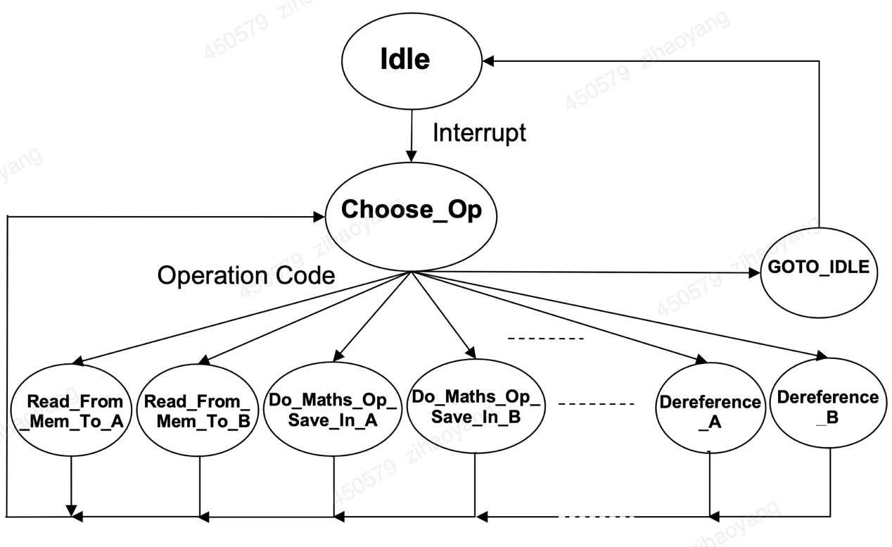

**Figure 13: Microprocessor’s state machine**

## 2.2 IR transmitter

The BASYS 3 board provides four 12-pin peripheral module connectors. Each is organised in two rows of 6-pins, with each row providing a power pin (Vdd @3.3V), a ground pin (GND), and four unique FPGA signals (see BASYS 3 reference manual, page 17). (Note that one of the connectors is designed for JXADC. Use any of the other three for this lab). Several 6-pin (or 12-pin) module boards that can attach to this connector are available from Digilent (see www.digilentinc.com for more information). For the purpose of this lab, we have developed our own 6-pin IR Transmitter module, which can be attached to any of the three peripheral module connectors. The following gives the circuit diagram of the IR Transmitter module.

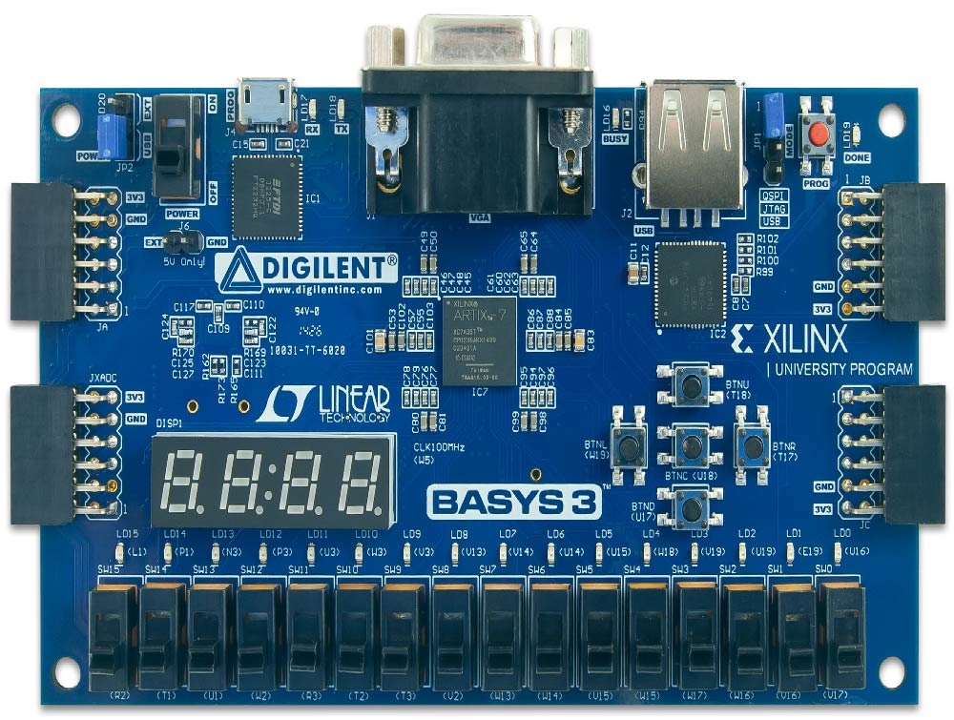

**Figure 14: Xilinx Basys3**

IR Transmitter is a module that generates the properly relative pulses to control the remote cars. Utilizing the Artix-7 chip of Xilinx Basys 3 FPGA with the above IR Transmitter peripheral module can realize the remote controller of toy car. The Figure 15 demostrates the transmitter circuit to generate pulses at the required 10Hz frequency.

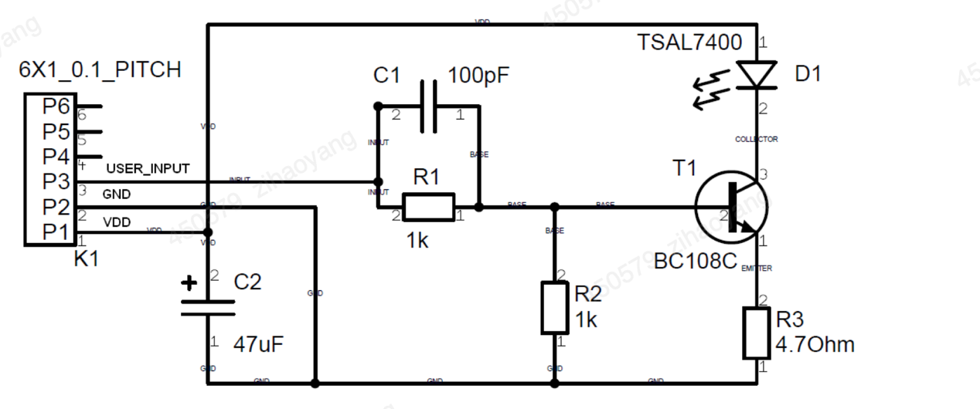

**Figure 15: IR transmitter circuit**

The following describes the packet details for each car type. These might vary from one car batch to another, so it is always wise to check the packet details using a logic analyzer.

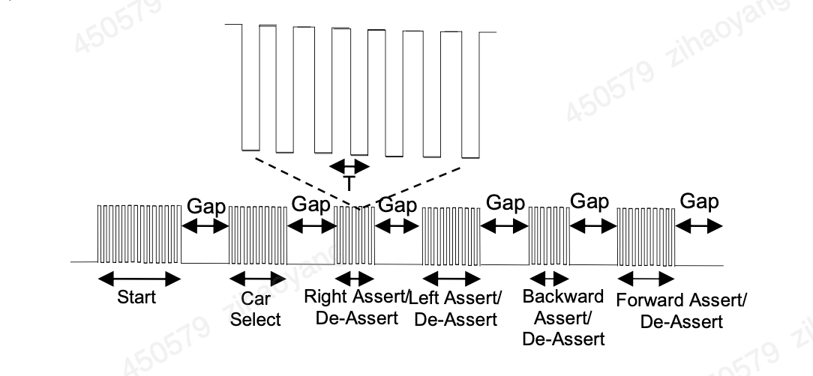

**Figure 16: Car Pulse Code**

Black Cars:  
In the case of black cars, the pulse frequency F = 1/T (see figure above) is equal to 40KHz. The following gives the specific number of pulses in each car control stage including start, gap, car selection (black), right assert/ de-assert, left assert/de-assert, backward assert/ de-assert and forward assert / de-assert as labelled in Figure 16:

* + Start = 88
  + Gap=40
  + CarSelect = 22
  + Right: If the right direction is to be asserted i.e. the car is to move to the right, the number of pulses here is set to 44, otherwise it is 22
  + Left: If the left direction is to be asserted i.e. the car is to move to the left, the number of pulses here is set to 44, otherwise it is 22
  + Backward: If the Backward direction is to be asserted i.e. the car is to move backwards, the number of pulses here is set to 44, otherwise it is 22
  + Forward: If the Forward direction is to be asserted i.e. the car is to move forwards, the number of pulses here is set to 44, otherwise it is 22

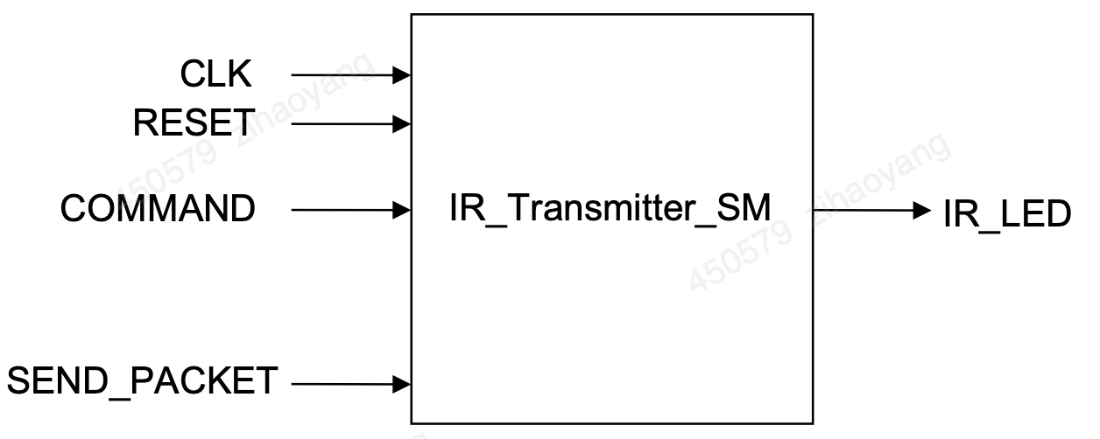

**Figure 17: IR Transmitter State Machine**

The state machine is illustrated in Figure 17 above where COMMAND input includes four bits: first bit represents the assert or de-assert the forward; second bit represents the assert or de-assert the backward; third bit represents the assert or de-assert the left; forth bit represents the assert or de-assert the right direction. Note that the state machine can only be activated to generate high-value ‘1’ to transfer to SEND_PACKET input for one clock cycle, which will eventually lead in the generation of one single packet of those shown Figure 16. This has to be done ten times per second for the car to respond to the command in question. A 10Hz counter is thus needed as illustrated in Figure 18 below.

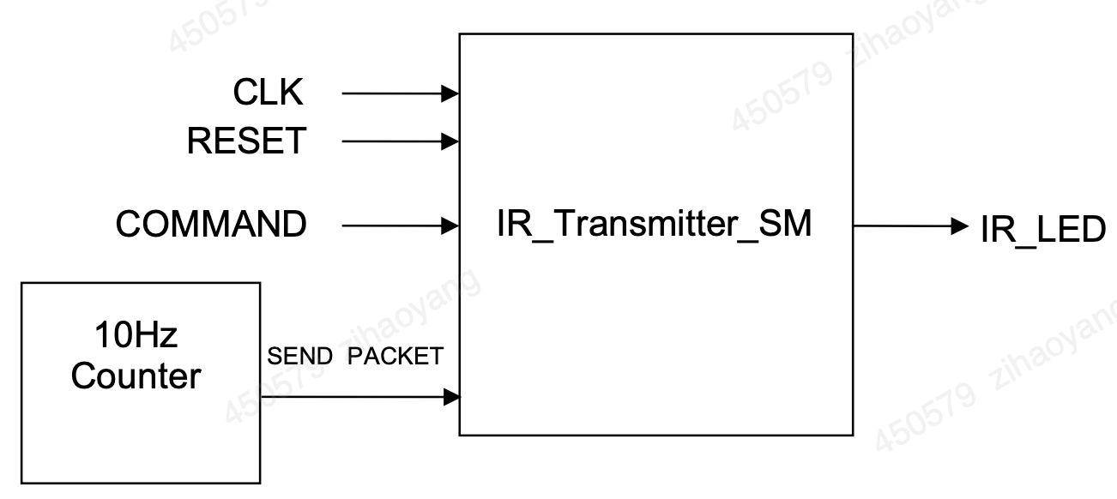

**Figure 18: IR transmitter Interface**

The Xilinx Basys 3 board frequency is 100MHz. Therefore, 10Hz Counter module is to generate 10Hz clock signal from Xilinx Basys 3 board 100Mhz frequency. So TenHz_cnt module is a frequency divider is a module that reduces the frequency of a signal. There are different methods to generate different duty cycles’ reduced frequency clock. Duty cycle is defined as the percentage of one period in which a signal is active (high) compared to its inactive (low) period. It's a measure of how long the signal stays in the active state during a single cycle and is crucial for a variety of applications in FPGA design. Here's a detailed look at the importance of duty cycle in FPGA:

1. Clock Signal Characteristics

**Clock Management**

* **Precise Timing Signals:** Proper duty cycle is crucial for generating precise clock signals that maintain a consistent and predictable timing reference. A 50% duty cycle (where the signal is high and low for equal periods) is often ideal for clock signals because it provides equal setup and hold times for timing-sensitive operations.
* **Jitter Reduction:** Maintaining an accurate duty cycle helps reduce clock jitter, which is variations in the clock signal's timing. Jitter can lead to timing errors in synchronous operations, so a stable duty cycle is important for reliable performance.

2. Data Integrity and Signal Quality

#### **Data Transmission**

* **Transmission Reliability:** For data transmitted in serial protocols (like UART, SPI), maintaining a consistent duty cycle ensures that bits are correctly distinguished as high or low. Any deviation in the duty cycle might lead to incorrect data interpretation.
* **Noise Immunity:** A uniform duty cycle improves the signal-to-noise ratio, which is particularly important in high-speed data transfer applications. This can help reduce errors caused by electromagnetic interference (EMI).

3. Pulse Width Modulation (PWM)

#### **Control and Signal Modulation**

* **PWM Control:** Duty cycle is a key parameter in Pulse Width Modulation (PWM) used for controlling power to devices like motors, LEDs, and other actuators. The effective power delivered to the device is directly proportional to the duty cycle.
  + **Motor Speed Control:** In motor control, adjusting the duty cycle of the PWM signal can vary the motor speed.
  + **Light Intensity Control:** For LEDs, the duty cycle can control brightness levels.
* **Signal Generation:** FPGAs frequently use PWM signals to generate analog signals. By adjusting the duty cycle, a wide range of analog outputs can be synthesized.

4. Power Management

#### **Efficient Power Utilization**

* **Dynamic Power Control:** Adjusting the duty cycle of control signals can help manage power consumption efficiently. Reducing the duty cycle reduces average power usage, which is fundamental in battery-powered and energy-sensitive applications.
* **Thermal Management:** Proper duty cycle management can lead to reduced heat generation, thereby addressing thermal constraints in high-performance FPGA systems.

5. Synchronization and Timing

#### **Multiphase Clock Generation**

* **Phase Alignment:** In applications where multiple clock phases are required, such as in data converters or certain DSP architectures, maintaining a consistent duty cycle across phases ensures proper synchronization.
* **Timing Closure:** Consistent duty cycles are essential for timing closure in complex FPGA designs, ensuring that all parts of a circuit meet their timing requirements.

6. Interfacing with External Components

#### **Compatibility with Peripherals**

* **External Device Communication:** Many external devices have specific duty cycle requirements for their input signals. Ensuring the FPGA-generated signals meet these requirements is crucial for proper interfacing.
* **Sensor Readings:** Some sensors and ADCs rely on specific duty cycles for accurate data sampling and clocking.

7. Debugging and Diagnostics

#### **Signal Analysis**

* **Waveform Integrity:** When debugging FPGA designs, analyzing the duty cycle of various signals can provide insights into performance issues or timing errors.
* **Test Patterns:** Controlled duty cycles can be used in test patterns to validate the correct operation of peripherals and interfaces [8].

Here is the specific Verilog code to realize:

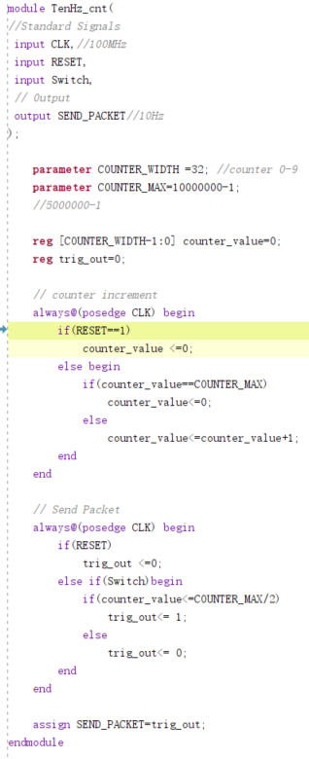

Because I set out to 1 only when the counter_value is less than half of COUNTER_MAX, otherwise it is 0, this ensures a duty cycle of 50%

Here is the simulation outcome:

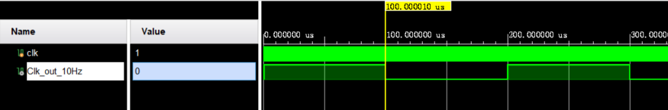

It is very obvious that Clk_out_10Hz is divided by 10000000 times from 100MHz clk.

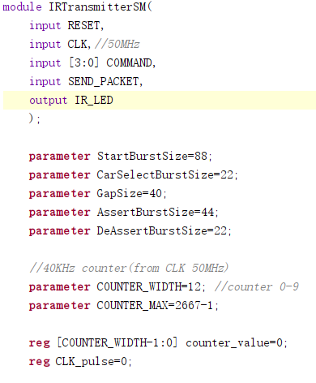

Here is the definition of parameters of car operation stages.

## 2.3 VGA Display

In order to display video onto a monitor screen, we will make use of the VGA port available on the BASYS 3 board. The latter uses 14 signals (carried by 14 FPGA pins, see Figure on page 11 of the BASYS 3 Reference Manual) [21] with 12-bit representing RBG color and two synchronization signals (HS – Horizontal Sync, and VS – Vertical Sync). HS and VS allow the VGA screen to align the incoming colour signals such that single pixel on the VGA monitor is coloured correctly. Colours are derived by a combination of the three primary colors: red, blue and green. Four bits are used for each colour (given 16 possible levels of each colour).

However, it is possible to use only 8 of the 12-bit colours, especially for compatibility with an 8 bit bus processor architecture. In this configuration, three bits are used for Red and Green (giving 8 possible levels of each colour) and two bits are used for Blue (giving four possible levels only, as the human eye is less sensitive to blue than it is to red and green). You could either chose to implement an 8-bit colour (connecting only the 3 LSBs of Red and Green, and 2 LSBs of Blue), or implement the full 12 bits colour but you will have to send the colour information twice on an 8-bit bus. In this description, we target the 8-bit configuration.

In this paper, I design a VGA driver targeted for FPGA implementation which can produce the necessary VGA signals (8 bit colour information and 2 synchronisation signals) to a VGA screen using a frame buffer that holds frame pixel values. The following will demostrate suggested design of the VGA driver.

VGA provides 640 x 480 pixels (horizontal x vertical) resolution. A VGA driver could be built from two modules as shown in the following figure:

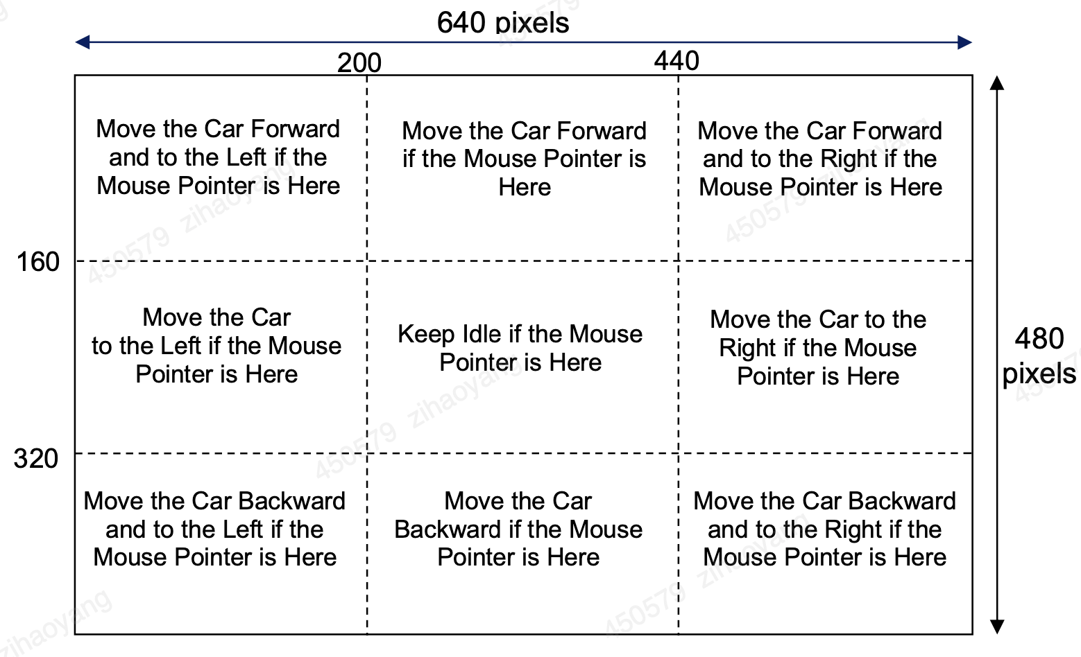

Figure 19: Car movement (command) depending on mouse pointer position

* - “Frame_Buffer”: A memory module which can be written value into by an another module such as microprocessor module, and read from by the “VGA_Sig_Gen” module (see Figure 20 below) for VGA display
* - “VGA_Sig_Gen”: A VGA signal generator module, which can read consecutive pixel colours in raster pattern, from the “Frame_Buffer” module, and outputs the VGA signals through the FPGA VGA display port pins

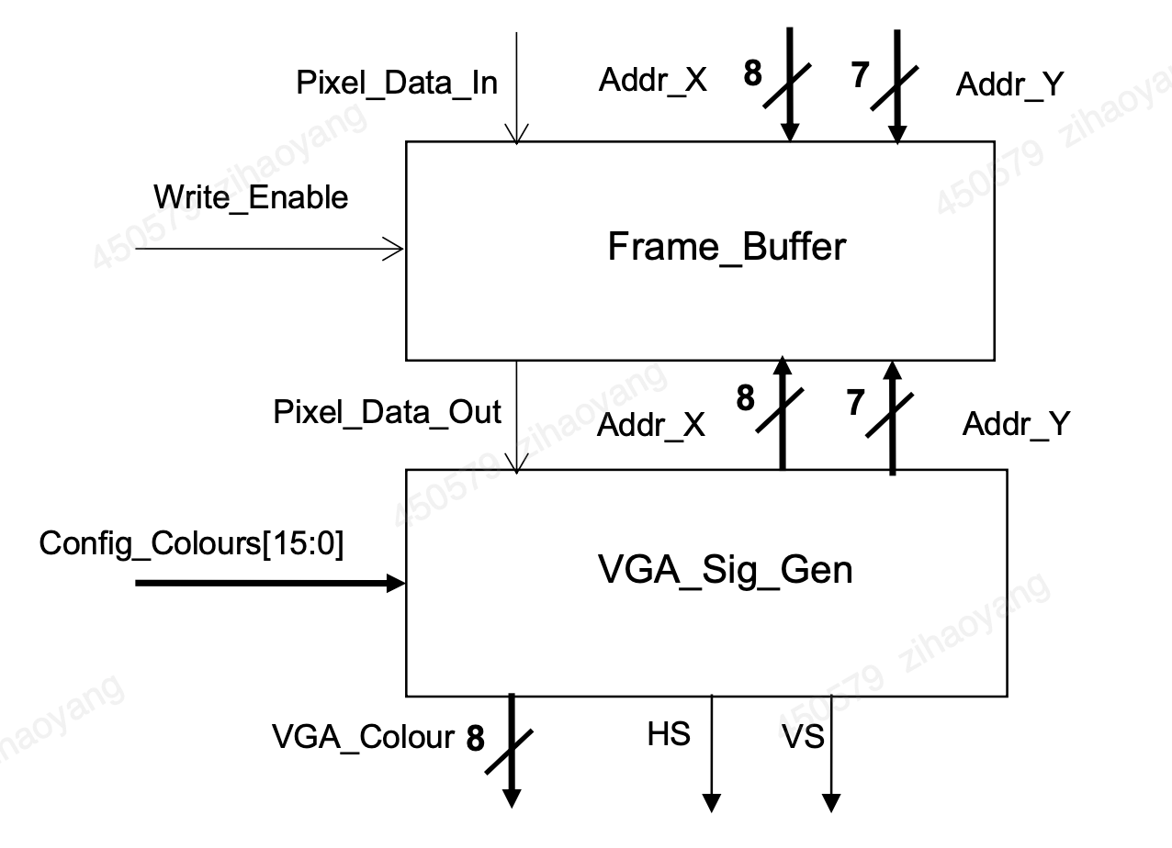

Figure 20: VGA Interface

Unfortunately, the FPGA chip on the BASYS 3 board does not have enough memory resources to store a full VGA frame with 8-bit pixels (i.e. 640 x 480 x 8 bits memory). In fact, few FPGA chips on the market can hold complete frames on-chip. Instead, off-chip memory (e.g. SDRAM) is often used to implement the frame buffer. The BASYS 3 board, however, does not have such external memory resource, which means that FPGA logic must be used to hold frame buffer data. To solve this problem, we can use a reduced colour resolution as well as a reduced pixel resolution to minimise memory storage requirements. In our suggested design, we will reduce the screen resolution by 4 in each direction i.e. each 4x4 pixel region on the screen would be represented by one single data element on the frame buffer, hence the above wordlength of the X and Y addresses in Figure 19 (i.e. 8 and 7 bits respectively instead of 10 and 9 bits for the 640 x 480 VGA resolution). We also reduce the colour resolution from 256 possible colours to just two colours (foreground and background) hence 1 bit data is sufficient for the colour information. A dual ported 256 x 128 1-bit memory should then be large enough to hold the whole frame buffer, which could be easily stored on the Artix-7 chip. Note that in the proposed code below, the foreground and background colours can be set by an external module e.g. a microprocessor, through input Config_Colour[15:0] (see Figure 19 above) which represents 2 x 8 bits of data for two possible 8-bit colours.

The following shows possible Verilog code for the Frame_Buffer module:

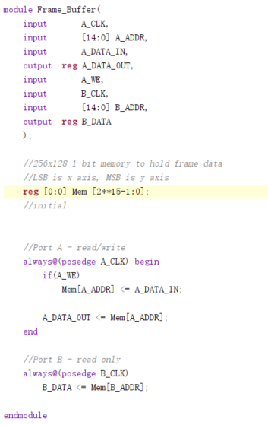  
The following shows Verilog code fragments for the VGA_Sig_Gen module:

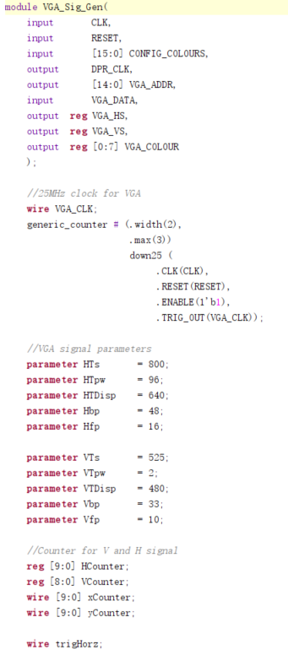

Since the VGA display needs 25MHz, I need to design a quarter frequency in this module called generic_counter.

Note that the VGA standard was designed for CRT monitors, and hence it is important to be aware of the timing of the original system, even if we are using a digital display. It should also be noted that in addition to the HS and VS timing definitions within the reference manual, the 8-bit colour signal needs to be set to 8'h00 (zero) whilst not during the display time.

During the development of this project, I complete your code based on the above, synthesis and verify your code with simple test benches, generate an FPGA bitstream and test on the BASYS 3 board. Test the above driver block by packaging it within a top-level wrapper module that produces colour configuration data and frame buffer, and then outputs the VGA signals to the FPGA VGA display ports pins. Display the following chequered image on the VGA display, changing colours every one second.

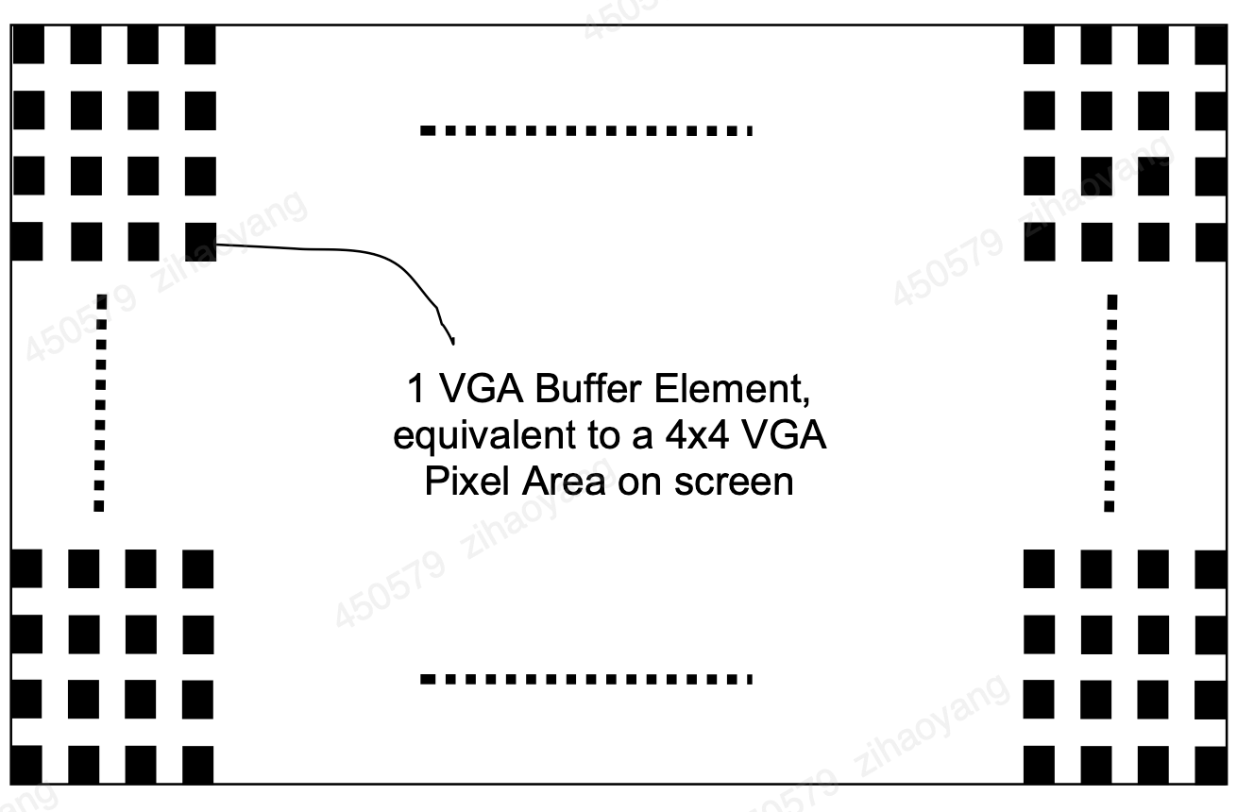

Figure 21: Chequered image to be displayed on the VGA screen

## 2.4 PS/2 and Mouse Driver

The USB connector on the BASYS 3 board can accommodate a USB mouse. Internally, the signals are converted to PS/2-like signals via a microcontroller as discussed on page 7 and 8 of the BASYS 3 reference manual. Hence, all we need do is implement a driver for a PS/2 mouse as the USB connector could be seen as just a wrapper which has already been implemented.

The PIC24 drives several signals into the FPGA – two are used to implement a standard PS/2 interface for communication with a mouse or keyboard (see figure 22 below).

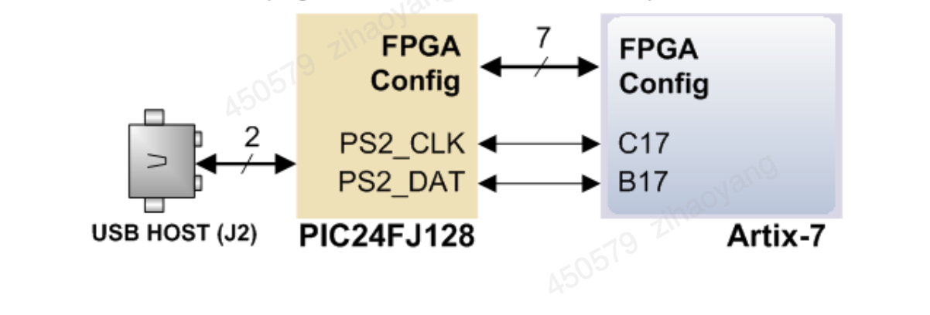

Figure 22: USB Host signals to PS/2 signal conversion

PS/2 devices use a two-wire serial bus (clock and data) to communicate with a host device

Communication is bidirectional and performed in packets of 11-bit words, with each word containing a start, stop and odd parity bit. The following describes the PS/2 mouse protocol in detail (NB. the PS/2 keyboard protocol can be found in the BASYS 3 user manual if you are interested in developing a keyboard interface but this is not required in this lab).

The mouse device only outputs a clock and data signal when it is moved. Otherwise, the clock and data lines remain at logic high (i.e. ‘1’). Open-Collector drivers are usually used to drive the two-wire bus between the mouse and host.

The device can send data to the host only when both data and clock lines are high. Because the host is the bus master, the device must check whether the host is sending data before driving the bus. The clock line is used for this purpose as a “clear to send” signal; if the host pulls the clock line low, the device must not send any data until the clock is released.

Communication is performed in 11-bit words, where each word consists of a ‘0’ start bit, followed by 8 bits of data (LSB first), followed by an odd parity bit (i.e. a bit that is set to ‘1’ if the number of 1’s in the 8 bits of data is even, and ‘0’ otherwise), and terminated with a ‘1’ stop bit. The odd-parity bit is used for error detection.

Data sent from a PS/2 device to a host is read on the falling edge of the clock signal, whereas data sent from a host to a PS/2 device is read on the rising edge of the clock signal. The following figure shows PS/2 signal timing for a device to host communication. Note the timing requirements which must be strictly adhered to. The clock frequency, for instance, must lie between 10 and 16.7 KHz.

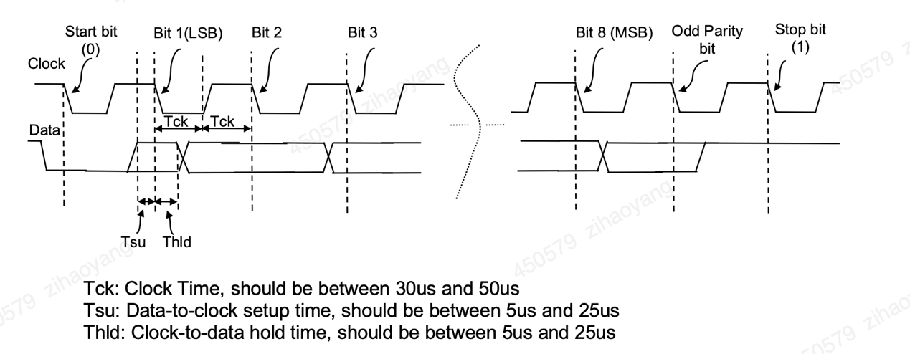

Figure 23: PS/2 Device to Host Signal Timing

The following figure shows PS/2 signal timing for a host to device communication. The host brings the clock line low first, for at least 100μs. It then brings the data line low and releases the clock line. The host then waits for the PS/2 device to bring the clock line low. After that, it sets or resets the data line with the first data bit, and waits for the device to bring clock line high. It then waits for the device to bring the clock line low before it sets/rests the data line with the second data bit. This process is repeated until all eight data bits are sent as well as the odd-parity bit. Next, the host releases the data line, and waits for the device to bring the data line low, and then the clock line low. Finally, the host waits for the device to release data and clock lines.

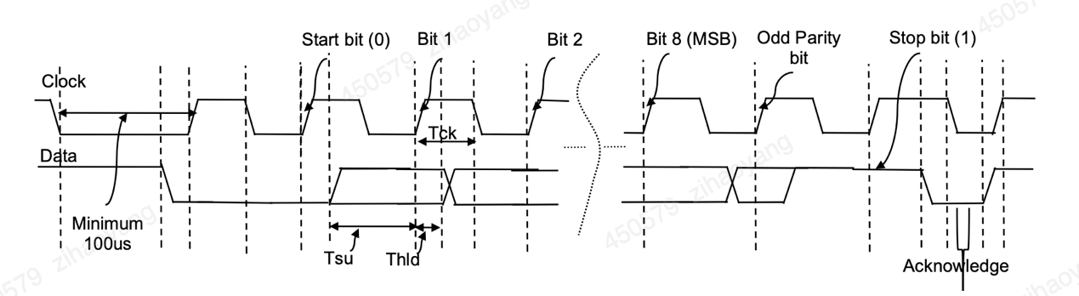

Figure 24: Host to PS/2 Device Signal Timing

Now that we have seen the low level PS/2 protocol, let us look at the high level host-mouse communication. At power-up, a typical host-mouse communication consists of the following steps:

1)  The host sends a Reset Command (consisting of byte “FF”) to the mouse,

2)  The mouse responds with an Acknowledgement byte “FA”,

3)  The mouse then goes through a self-test process and sends “AA” when this is passed. Then a mouse ID byte “00” is sent to the host, after which the host knows that the mouse is functioning well and ready to transmit data,

4)  The host sends byte “F4” to instruct the mouse to “Start Transmitting” its position information,

5)  The mouse acknowledges the “Start Transmitting” command by sending byte “FA” back to the host,

6)  After this, the mouse starts transmitting its position information in the form of 3 bytes at a sample rate that can be set by the host (the default is 100Hz)

however that in the Basys3 FPGA board, probably due to the USB to PS/2 conversion, F4 instead of FA is returned, and parity test fails. Hence in state 8 of MasterStateSM module, the acknowledgement code have been changed to F4, and parity check skipped.

Thus, each data transmission from the mouse to the host after initialisation consists of 33 bits, where bits 1 (first bit), 12, and 23 are ‘0’ start bits; bits 10, 21, and 32 are Odd-Parity bits; and bits 11, 22, and 33 are ‘1’ stop bits. The three-byte data fields contain status and movement data as shown in the figure below.

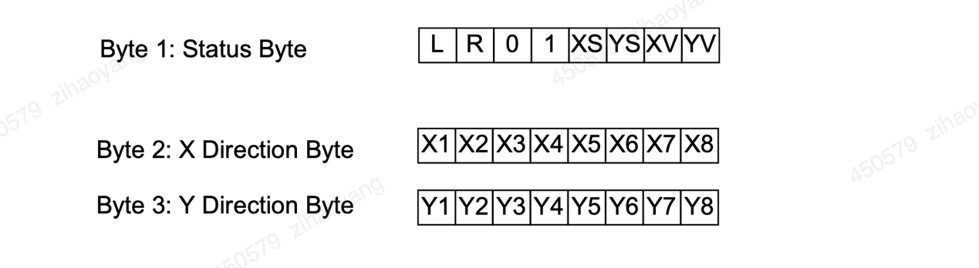

The mouse reports a relative coordinate system whereby a move to the right generates a positive number in the X Direction Byte field, and a move to the left generates a negative number in this field. Similarly, a move upwards generates a positive number in the Y Direction Byte field, and a move downwards generates a negative number. Note that the X and Y Direction Bytes represent the magnitude of the rate of mouse movement, the larger the number the faster the mouse is moving. Bits XS and YS in the Status Byte are the sign bits, whereby a ‘1’ indicates a negative number, whereas XV and YV bits are movement overflow indicators, whereby a ‘1’ means overflow has occurred. The L and R fields in the Status Byte indicate that the left and right button have been pressed, respectively (‘1’ indicates the button has been pressed).

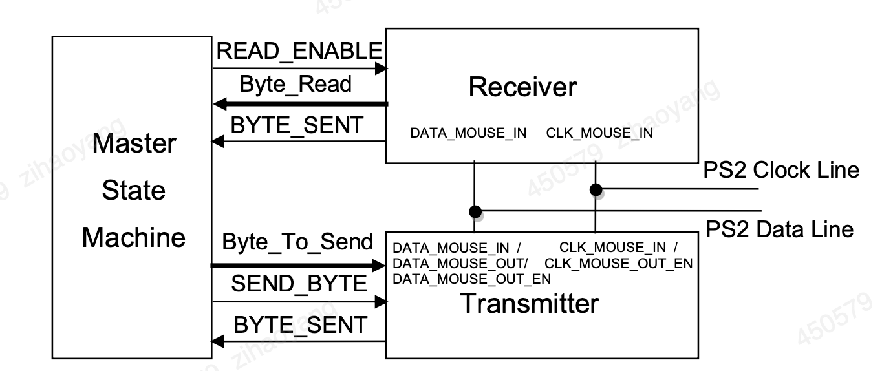

Figure 25: Mouse Interface: Simplified Block Diagram

**2.5 7-segments LED**

The seven-segment display, also known as a "7-segment display," consists of seven individual LEDs, arranged in a rectangular pattern as illustrated. Each LED is called a segment because when illuminated, it forms part of the numerical digit (both decimal and hexadecimal) to be displayed.

In some configurations, an additional eighth LED is included in the same package to indicate a decimal point (DP). This is particularly useful when multiple seven-segment displays are connected together to display numbers greater than ten.

Each of the seven LEDs in the display has a designated positional label, ranging from 'a' to 'g', with one of its connecting pins extending directly out of the rectangular plastic casing. The other pins are interconnected to form a common pin.

By applying a forward bias to the appropriate pins of the LED segments in a specific sequence, certain segments will light up while others remain dark, thereby generating the desired numerical character on the display. This setup allows for the display of all ten decimal digits (0 through 9) on the same seven-segment display.

The common pin helps identify the type of seven-segment display. Each LED has two connecting pins, one named the "Anode" and the other named the "Cathode." Consequently, there are two types of LED seven-segment displays: Common Cathode (CC) and Common Anode (CA).

The distinction between these two types lies in their connections. In a common cathode display, all the cathodes of the seven segments are directly connected together. Conversely, in a common anode display, all the anodes of the seven segments are connected together. The illumination of the segments is as follows:

In a common anode LED display, the seven anodes of the segments are connected to a single common anode node, while their cathodes are separate, as shown in the figure 26. The DP-segment is used to illuminate the decimal point, but we will omit it for now since it does not contribute to the numerical value displayed by the seven-segment display.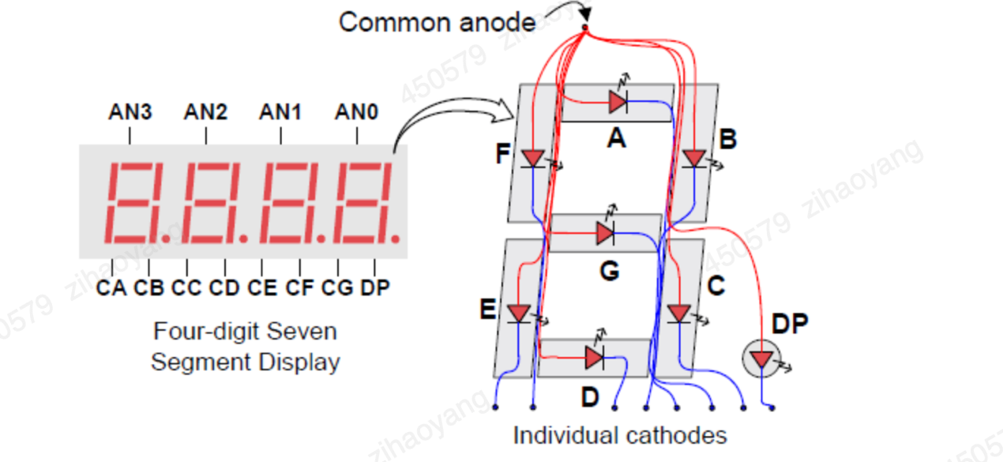

Figure 26: 7-segment LED structure

7-segment Display Truth Table

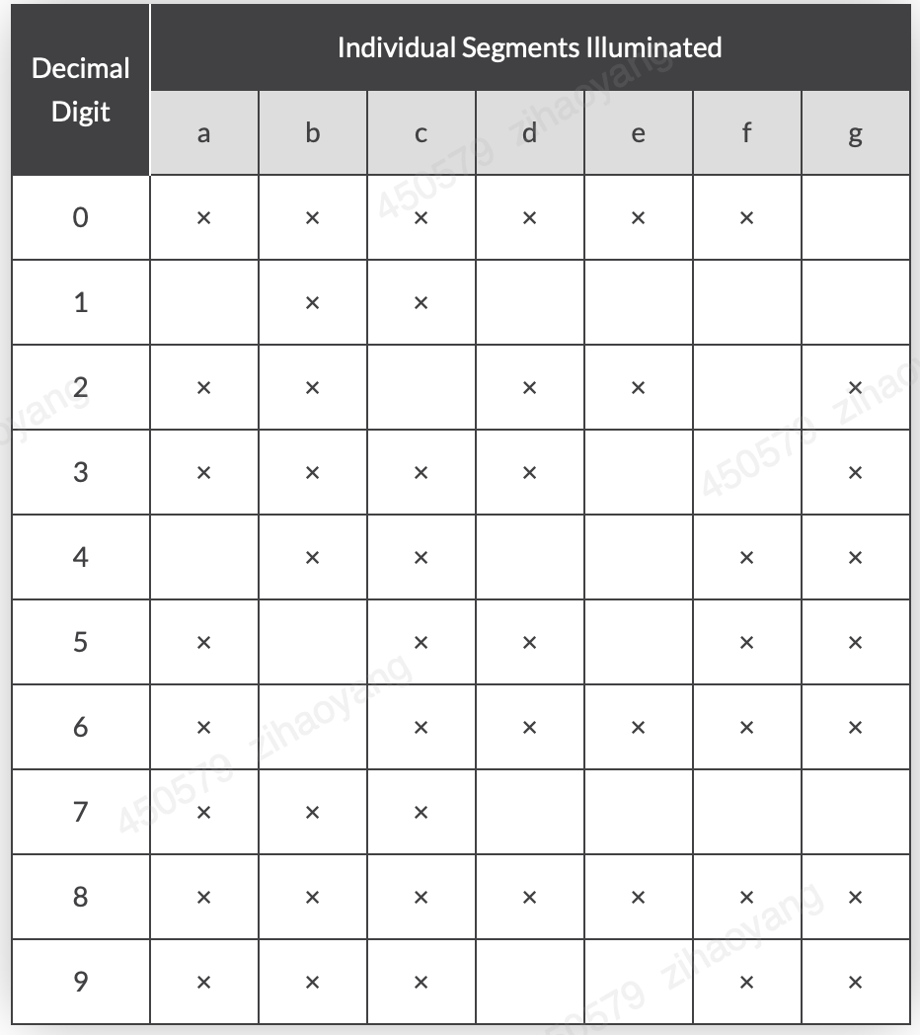

Table 4

Though a 7-segment display might appear as a single unit, it actually comprises seven individual LEDs housed within one package. These individual LEDs require protection from excessive current. LEDs generate light when forward biased, and the intensity of this light is roughly proportional to the forward current.

Thus, increasing the current linearly boosts the LED's light intensity. However, to safeguard the LEDs from potential damage, the forward current must be managed and limited to a safe level using an external resistor.

The forward voltage drop across a red LED segment is relatively low, around 2 to 2.2 volts (whereas blue and white LEDs can drop as much as 3.6 volts). To ensure proper illumination, LED segments should be connected to a voltage source higher than this forward voltage, with a series resistor used to limit the forward current to a safe value.

For a standard red 7-segment display, each LED segment typically draws about 15 mA for correct illumination. Thus, in a 5-volt digital logic circuit, the current-limiting resistor should be about 200Ω, calculated as (5V - 2V) / 15mA, or rounded up to the nearest preferred value of 220Ω.

To understand the connection of the display segments with a 220Ω current-limiting resistor, consider the configuration shown in the circuit diagram below.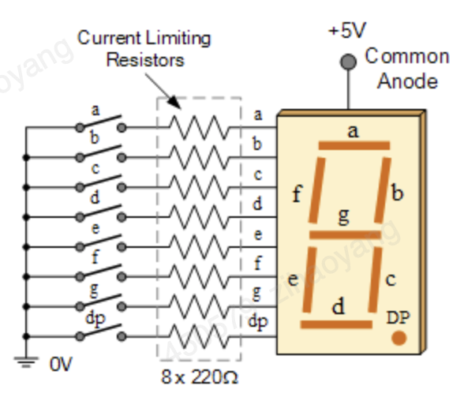

Figure 27: 7-segment circuit

In this example, the segments of a common anode display are controlled using switches. When switch 'a' is closed, current flows through the 'a' segment of the LED, passes through the current limiting resistor connected to pin 'a', and continues to 0 volts, completing the circuit. Consequently, only the 'a' segment will illuminate. Therefore, a LOW condition (switch connected to ground) is necessary to activate the LED segments on this common anode display.

To display the decimal number "4," you would close switches 'b', 'c', 'f', and 'g', thereby illuminating the corresponding LED segments. In a similar manner, to display the number "7," switches 'a', 'b', and 'c' would need to be closed.

However, operating 7-segment displays using individual switches is not practical for most applications. Here is the 7-segment decoder code:

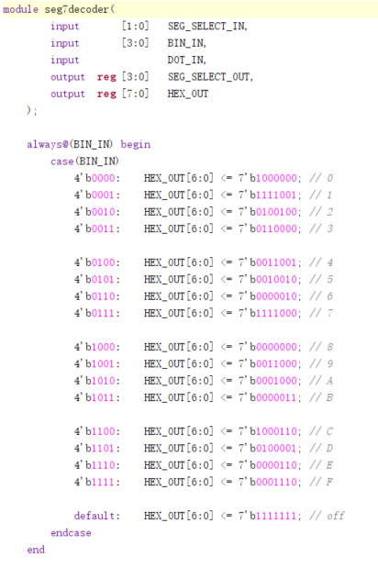

## 2.6 Interrupt

A computer CPU is a highly orderly entity, following program instructions one by one in a precise and predictable manner. Interrupts, however, disrupt this order. They can occur unexpectedly, alerting the CPU that a significant external event has happened, requiring it to stop its current task and respond as quickly as possible. Originally, interrupts were used for emergency external events, such as power failures, system overheating, or major subsystem failures, to get the CPU's immediate attention. However, the power of interrupts was soon recognized. Over time, more subsystems gained the capability to generate interrupts, leading to increased complexity in interrupt structures and the need to prioritize different interrupts.

To work effectively with interrupts, it is crucial to understand both the hardware interrupt structure and the programming techniques required to handle them. Different microcontrollers have varied interrupt structures, typically featuring multiple interrupt sources, both internal and external. A generic structure illustrating the main hardware principles is shown in Figure 6.1. On the left, we see an interrupt source labeled ‘Interrupt X’. When an interrupt occurs, it sets an S–R bistable latch, recording the interrupt even if it is momentary. The output of this latch, known as the 'interrupt flag', is gated with an enable signal ‘Interrupt X Enable’. If this enable signal is high, the interrupt signal proceeds to an OR gate. If the enable signal is low, the interrupt signal is blocked. Enabled interrupt signals are combined in the OR gate, whose output goes high if any interrupt input is high. This output is further gated with a ‘Global Interrupt Enable’. Only if this global enable is high can any interrupt signal reach the CPU. After the CPU responds to an interrupt, the interrupt flag must be cleared. In some processors, this is done automatically by the CPU; in others, it must be done programmatically within the code [9].

In our system architecture presented in Figure 8 above, interrupts come from two possible sources: 1) the mouse, when it is moved or clicked, and 2) the timer, which outputs an interrupt signal every one second. In general, an interrupt is an asynchronous signal from hardware indicating the need for attention, or a synchronous event in software indicating the need for a change in execution. Multiple hardware interrupts can be serviced through an interrupt controller which acts as another bus peripheral whose task is to service interrupts before they are sent to the microprocessor. This includes dealing with priorities for instance. In this lab, interrupts will be served on a “first-come first-served” basis. If two interrupts arrive at exactly the same time, the mouse interrupt will be dealt with first.

When an interrupt request is received by the microprocessor, the current program execution is suspended after the execution of the current instruction. The context information is then saved so that execution can return to the current program after interrupt servicing. In the case of our microprocessor, the context consists in the address of the next instruction to be executed by the interrupted process. After context saving, execution is transferred to an interrupt handler to service the interrupt. The start (or base) address of the interrupt handler’s service routine is usually predefined, for each interrupt line, in a particular memory address. In our case, the memory address where the base address of the mouse interrupt handler’s service routine is stored is “FF”, whereas that of the timer is “FE”. This means that whenever a mouse interrupt is received, for instance, the microprocessor fetches the base address of the mouse interrupt handler’s service routine to be executed from address “FF”. In other words, the content of address “FF” will be the address of the first instruction to be executed by the interrupt handler’s service routine.

The following gives you a possible Verilog code to implement the Timer peripheral. Code for the seven-segment display peripheral has already been given to you as part of the mouse interface module (you would need to wrap your existing peripheral codes with bus interfaces though), while the LEDs peripheral is straightforward to implement.

## 2.7 Rom

ROM (Read-Only Memory) holds significant importance in RISC-V based microprocessor designs. Given the flexibility, openness, and scalability of the RISC-V architecture, ROM plays a crucial role in multiple aspects of the microprocessor's operation [10]. Here’s a detailed outline of the importance of ROM in a RISC-V based microprocessor:

1. Bootstrapping the Processor

#### **Bootloader Storage**

* **System Initialization:** In a RISC-V microprocessor, the ROM typically stores the bootloader, which is the initial program that executes when the system powers up. This bootloader is responsible for initializing hardware components and preparing the system for operation.
* **Secure Boot:** ROM can contain a secure bootloader that verifies the integrity of the firmware before it is loaded, ensuring that the system boots securely.

2. Storing Firmware and Software

#### **Embedded Firmware**

* **Firmware Storage:** ROM is used to store the firmware required for the microprocessor’s operation. This includes basic input/output system (BIOS), operating systems, and system-level utilities.
* **Immutable Storage:** Since ROM is immutable, it ensures that the fundamental software required to operate the microprocessor remains unchanged and reliable across reboots.

3. Efficient Storage of Constants and Lookup Tables

#### **Fixed Data Storage**

* **Lookup Tables:** ROM efficiently stores fixed data such as lookup tables, mathematical constants, and predefined data arrays. These are frequently used in RISC-V implementations for tasks such as floating-point operations and complex mathematical computations.
* **Microcode Storage:** For certain RISC-V implementations that use microcoded instructions, ROM can store the microcode that defines the behavior of complex instructions.

4. Performance Optimization

#### **Speed and Efficiency**

* **Fast Access Times:** ROM provides fast access to stored data and instructions, which is crucial for the performance of the microprocessor. The speed at which the RISC-V processor can fetch instructions from ROM directly impacts its overall efficiency.
* **Instruction Fetching:** In the initial stages of booting, the processor fetches instructions directly from ROM, ensuring quick and reliable execution of critical startup routines.

5. Supporting RISC-V’s Modularity and Extensibility

#### **Custom Extensions**

* **Custom Instructions:** RISC-V’s open and extensible nature allows for the addition of custom instructions. ROM can store the microcode or control logic associated with these custom instructions, enabling quick access and execution.
* **Debug and Diagnostics:** ROM can store diagnostic routines and debug support code, facilitating easy debugging and validation during development and post-deployment support.

6. Interfacing and Integration

#### **Peripheral Initialization**

* **Peripheral Drivers:** ROM can store drivers and initialization code for various peripherals and hardware components attached to the microprocessor. Ensuring these drivers reside in ROM guarantees their availability and correct operation at system start.
* **Configuration Data:** ROM can include configuration parameters for various components, making it easier to achieve consistent and reliable system startup configurations.

7. Power Management

#### **Efficient Operation**

* **Embedded ROM in Low-Power Modes:** In power-sensitive applications, data and code stored in ROM can be accessed with less power compared to writeable memory types. This helps in maintaining efficient operation during low-power modes.
* **Power-On Initialization:** During power-on, the microprocessor can quickly initialize and transition to a working state by executing the initialization code stored in ROM.

Here is the Verilog code of how ROM could be defined and used in a RISC-V based microprocessor:

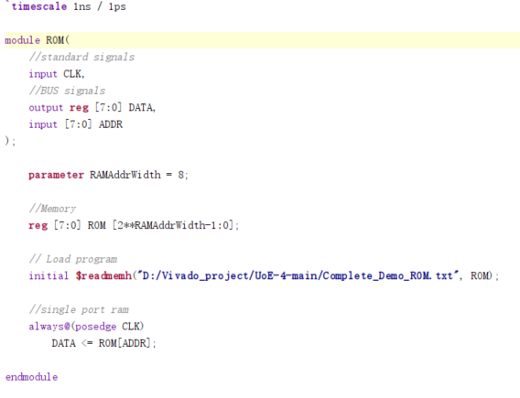

In conclusion, ROM is a vital component in microprocessor design within FPGAs, providing essential functions such as boot and initialization storage, firmware and software storage, security, performance optimization, and efficient integration with FPGA logic. Its immutability and reliability make it indispensable for secure and consistent system behavior, while its ability to store crucial code and data contributes significantly to the overall design and operational efficiency of FPGA-based microprocessors.

## 2.8 RAM

Random Access Memory (RAM) is a fundamental component in the design of RISC-V based microprocessors. The importance of RAM in such designs can be understood from multiple perspectives, including system performance, functionality, flexibility, and development process. Below are the details outlining the importance of RAM in RISC-V microprocessor design [11]:

1. **Execution of Programs**

#### **Instruction Fetching and Execution**

* **Program Storage**: RAM stores the executable code of applications and the operating system. By holding active instructions, it enables the microprocessor to fetch, decode, and execute instructions at high speed.
* **Instruction Cache (ICache)**: RAM is often used to implement instruction caches, enhancing the efficiency and performance by reducing the latency associated with fetching instructions from slower storage like ROM or external memory.

#### **Data Storage and Access**

* **Data Cache (DCache)**: RAM is also used for data caches, allowing rapid access to frequently used data, which is crucial for high-performance computing and real-time applications.
* **Temporary Data Storage**: RAM stores temporary data and variables used during program execution, facilitating quick read/write operations necessary for efficient computation.

2. **System Performance**

#### **Latency and Bandwidth**

* **High-speed Access**: RAM provides low-latency, high-bandwidth access to data. This is crucial for maintaining the performance of the microprocessor as it ensures data and instructions are readily available without significant delays.
* **Parallelism**: Modern RAM designs support multiple parallel accesses, allowing the RISC-V processor to perform multiple reads/writes simultaneously, further boosting performance.

3. **Flexibility and Scalability**

#### **Dynamic Operation**

* **Dynamic Memory Allocation**: RAM enables dynamic memory allocation, allowing programs to request and release memory as needed during execution. This is essential for the efficient management of memory resources, particularly in complex applications and operating systems.
* **Multi-Tasking Support**: In multi-tasking environments, RAM provides the necessary support for context switching by storing the state of each task or process. This allows the RISC-V microprocessor to efficiently manage and switch between multiple tasks.

#### **Expandable Memory**

* **Scalability**: Systems can be designed with expandable RAM, allowing for increased memory capacity as needed. This is particularly important in applications that require handling large datasets or running memory-intensive applications.
* **Modular Design**: RISC-V systems can be designed with different RAM modules for different purposes, such as separate instruction and data caches or additional RAM for specific peripherals, providing modularity and flexibility in design.

4. **Development and Prototyping**

#### **Testing and Debugging**

* **Real-time Prototyping**: RAM allows for real-time testing and debugging of applications and firmware. Developers can load and modify code in RAM during debugging sessions to quickly test changes and iterate on the design.
* **Simulation Support**: During the design and simulation of a RISC-V microprocessor, RAM provides a realistic environment for testing programs and verifying processor behavior under different scenarios.

5. **System Memory Hierarchy**

#### **Memory Management**

* **Hierarchical Memory**: RAM is a crucial part of the memory hierarchy, often positioned between the high-speed cache and slower storage like disk drives. This hierarchical approach ensures efficient data handling and access speeds appropriate to different levels of data usage.
* **Memory Maps**: RAM is used to create memory maps, allowing the microprocessor to access different memory regions efficiently. This includes mapping peripheral devices, stack, heap, and other memory areas required for structured data management.

6. **User Experience and Application Performance**

#### **Responsive Systems**

* **Interactive Applications**: For interactive and GUI-based applications, RAM ensures that data required for user interactions is quickly accessible, providing a smooth and responsive user experience.
* **Multimedia Processing**: RAM is critical for multimedia applications such as video and audio processing, where large amounts of data need to be processed and accessed in real-time.

Practical Example and Application

Here's the designed Verilog code illustrating RAM usage in a RISC-V microprocessor design with a focus on main memory for storing instructions and data.

**RAM Module Definition in Verilog**

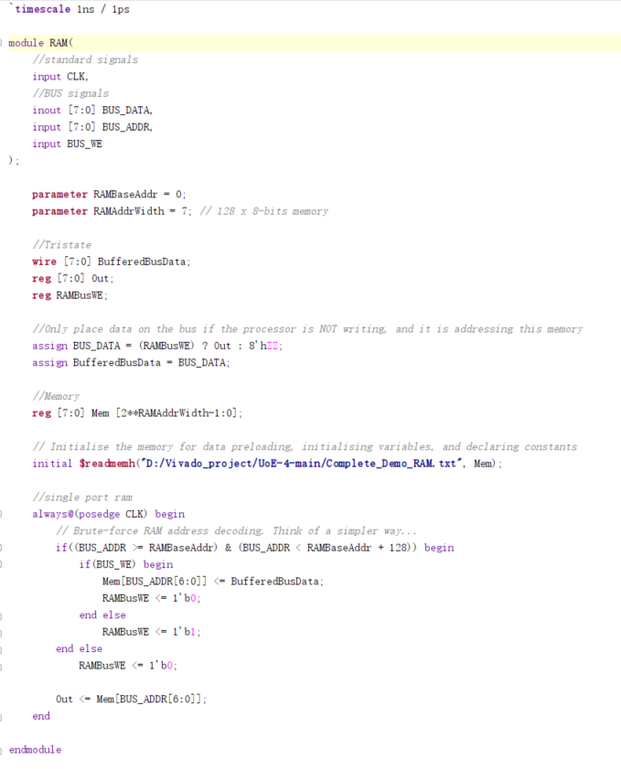

# 3.Software Application and Test Result

## 3.1 Assembly code and machine code

Assembly language is a low-level programming language designed to communicate directly with a computer’s hardware. Unlike machine language, which consists of binary and hexadecimal symbols, assembly languages are constructed to be more human-readable [12].

Low-level languages such as assembly serve as an essential bridge between the computer's hardware and high-level programming languages like Python or JavaScript, in which modern software is typically developed.

At its core, a computer executes the most basic instructions as binary codes, composed of ones and zeros. These binary codes translate directly into the "on" and "off" states of the electric currents in the computer’s circuits. These basic codes constitute "machine language," the most fundamental type of programming language.

However, programming modern software by explicitly writing ones and zeros is impractical for humans. Therefore, human programmers utilize various layers of abstraction to articulate commands in a more intuitive format.

Modern programmers use "high-level languages" characterized by intuitive syntax, such as full English words, sentences, and logical operators like “and,” “or,” and “else,” which are familiar in everyday usage.

Ultimately, high-level commands need translation into machine language. Instead of manual translation, programmers rely on assembly languages to automatically convert between high-level and low-level languages. Developed in the 1940s, assembly languages were an essential step forward. Though modern developers rarely interact directly with assembly languages, they remain crucial for the computer's overall functioning.

Assembly languages were originally designed with a one-to-one correspondence between mnemonics (symbolic code for instructions) and machine language instructions. An example illustrates this point. A systems program known as an assembler translates mnemonics into machine language. These assemblers were eventually enhanced with macro expansion capabilities, allowing programmers to define parameterized abbreviations for common instruction sequences. Despite these enhancements, the correspondence between assembly language and machine language remained clear and explicit. Programming was inherently machine-centered: each type of computer needed to be programmed in its own assembly language, and programmers thought in terms of the machine's executable instructions.

One of the most common operations in computing is addition. Figure 25 presents code for adding variables b and c and storing the result in variable a. The left side shows the code in a high-level language (compatible with C, C++, and Java syntax), while the right side translates the code into RISC-V assembly language. Note that statements in a C program end with a semicolon.

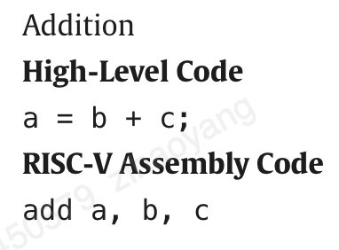

Figure 28: Addition codes

The first part of the assembly instruction, "add," is called the mnemonic and specifies the operation to be performed. In this case, the operation is executed on the source operands b and c, with the result stored in the destination operand a.

The RISC-V instruction set optimizes common operations by including only simple, frequently used instructions. This keeps the number of instructions small, allowing the hardware needed to decode instructions and their operands to be straightforward, compact, and fast. More complex and less frequent operations are handled by sequences of multiple simple instructions. Thus, RISC-V represents a reduced instruction set computer (RISC) architecture. In contrast, architectures like Intel’s x86, which incorporates numerous complex instructions, are classified as complex instruction set computers (CISC). For instance, x86 has a “string move” instruction to copy a string from one memory location to another, an operation that could require many simple instructions in a RISC machine. The complexity of CISC instructions adds hardware and overhead, potentially slowing down simpler instructions. The Preface of our text discusses several simulators and tools for compiling and simulating both C and RISC-V assembly code [13].

Assembly language generally executes faster than high-level languages and makes it easier to insert or delete code components. It often requires fewer instructions to complete a task compared to other languages. Programmers seeking greater control over their hardware often use assembly languages because they allow direct manipulation of computer hardware. Due to its speed and efficiency, some programs are specifically written in assembly language to maintain smaller code sizes.

However, assembly language has its drawbacks. Long programs written in assembly typically require substantial computing power and may not run on smaller computers. The syntax is often harder to memorize, making it more complex and time-consuming to code. Additionally, assembly language is generally not portable across different computer systems, similar to how employee benefits don’t transfer between companies; the language cannot be seamlessly translated to different machines.

Pros:

* Execution may be simpler compared to other languages
* Execution is usually faster compared to other languages
* Allows for direct control over hardware
* Code may remain smaller compared to other languages

Cons:

* Programming may be more challenging to pick up compared to high-level languages
* Syntax of assembly languages is difficult
* Not portable between machines

## 3.2 Machine code

Machine code, also known as machine language, is the fundamental language of computers. It is directly read by the computer's central processing unit (CPU) and consists of binary numbers, appearing as a lengthy sequence of zeros and ones. Ultimately, the source code from any human-readable programming language must be translated into machine language by a compiler or an interpreter, as binary code is the only language that computer hardware can natively understand [14].

Each CPU has its own unique machine language. The processor reads instructions, which direct the CPU to carry out simple tasks. These instructions consist of a specific number of bits. For instance, in an 8-bit instruction set, the first 4 bits (the opcode) indicate the operation to perform, while the next 4 bits (the operand) specify the data to be used.

Depending on the processor, a computer’s instruction sets may be uniform in length or may vary based on the specific command. The architecture of the processor determines the patterning of these instructions. Firmware or the CPU's internal wiring manages the execution of instructions.

Today, human programmers seldom interact directly with machine code. During debugging at a low level, developers might use a printout displaying the program in its machine code form. This printout, known as a dump, is quite challenging to work with. Tools used to create dumps often represent four bits with a single hexadecimal digit to make machine code somewhat easier to read and include additional information about the computer’s operation, such as the address of the instruction being executed when the dump was initiated.

Advantages of Machine Language

1. Machine languages enable faster execution since they are in binary form.
2. Machine language does not require translation, as it is already in a straightforward binary format.
3. The CPU executes machine language directly.
4. The evolution of computer systems and operating systems over time has been driven by machine language.
5. Machine languages are used in developing advanced computer systems.

Disadvantages of Machine Language

1. Machine language is complex to comprehend and memorize.
2. Coding in machine language is time-consuming.
3. Resolving bugs and errors in machine language code is very difficult.
4. Codes written in machine language are more error-prone.
5. Machine languages are not easy to modify.
6. Machine language is platform-dependent.

Assembly Language: A Low-Level but Readable Solution

While assembly language is still low-level, it is more readable and writable than binary language. It typically maintains a one-to-one correspondence with machine code instructions and uses mnemonics (e.g., MOV for move, ADD for addition) and symbolic addresses for instructions. Like machine language, assembly language is specific to a particular CPU architecture.

Assembler

An assembler translates assembly language code into machine code, bridging the gap between human-readable instructions and binary language.

Machine and Assembly Comparison and Relationship

1. **Level of Abstraction**:
   * **Binary Language**: Directly corresponds to the machine-level instructions that the CPU executes.
   * **Assembly Language**: Provides a slightly higher abstraction level with more human-readable mnemonics and labels.
2. **Ease of Use**:
   * **Binary Language**: Extremely difficult to read, write, and debug.
   * **Assembly Language**: Easier to understand and write than binary language but still requires knowledge of the hardware.
3. **Translation**:
   * **Binary Language**: No translation needed as it's executed directly by the CPU.
   * **Assembly Language**: Requires an assembler to translate assembly instructions into machine code.
4. **Portability**:
   * Both binary and assembly languages are not portable across different CPU architectures. Code written for one type of processor typically will not run on another without modification.

Practical Use Cases

When to Use Binary Language: Rarely written by humans directly due to its complexity.

Used primarily in development and debugging tools, or in certain high-performance computing situations where you may manually manipulate binary code (e.g., embedded systems programming).

When to Use Assembly Language:

Embedded Systems: Where low-level hardware manipulation and optimization are required.

Performance Optimization: For performance-critical portions of code that require fine-tuned optimization.

Device Drivers: To interface directly with hardware.

Reverse Engineering: For analyzing and understanding compiled binary programs.

Example in RISC-V Assembly Language

Assembly language and binary language (machine code) are both low-level programming languages that are closely related to the architecture of a computer's hardware. Both play crucial roles in the development and functioning of software systems, but they operate at different levels of abstraction.

In this project, I choose to use machine code to realize remote car control because it is hard to write and implement a compiler due to the FPGA resource limitation.

|  |  |  |
| --- | --- | --- |
| Address (Hex) | Value (Hex) | Comment |
| //VGA |  |  |
| @0x00 | 0x00 | //output of Hcounter |
| @0x01 | 0x00 | //output of Vcounter |
| @0x02 | 0xA0 | //max of Hcounter 160 |
| @0x03 | 0x78 | //max of Vcounter 120 |
| @0x04 | 0x00 | //constant zero |
| @0x05 | 0x01 | //pixel data |
| @0x06 | 0x00 | //H index |
| @0x07 | 0x00 | //V index |
| @0x08 | 0x00 | //H base addr 1 0 |
| @0x09 | 0x35 | //H base addr 2 53 |
| @0x0A | 0x6A | //H base addr 3 106 |
| @0x0B | 0x00 | //V base addr 1 0 |
| @0x0C | 0x28 | //V base addr 2 40 |
| @0x0D | 0x50 | //V base addr 3 80 |
| @0x0E | 0x01 | //constant one |
| //IR transmitter |  |  |
| @0x0F | 0x09 | //left mouse button |
| @0x10 | 0x0A | //1010 Forward left |
| @0x11 | 0x08 | //1000 Forward |
| @0x12 | 0x09 | //1001 Forward right |
| @0x13 | 0x02 | //0010 Left |
| @0x14 | 0x00 | //0000 Idle |
| @0x15 | 0x01 | //0001 Right |
| @0x16 | 0x06 | //0110 Backward left |
| @0x17 | 0x04 | //0100 Backward |
| @0x18 | 0x05 | //0101 Backward right |
| @0x19 | 0x00 | //H |
| @0x1A | 0x00 | //V |
| @0x1B | 0x00 | //0 |
| @0x1C | 0x01 | //1 |
| @0x1D | 0x02 | //2 |
| @0x1E | 0x10 | //16 |
| @0x1F | 0x13 | //19 |

Table 4

RAM is volatile memory, which means that the data stored in it is lost when the power is turned off. RAM is typically used to store the operating system, application programs, and data that the computer is currently using. Therefore, in this project, I save various parameters like car direction navigation control command (such as Forward, Backward, Left, Right and so on), VGA screen display address and some specific constants.

ROM is non-volatile memory, which means that the data stored in it is retained even when the power is turned off. ROM is typically used to store the computer’s BIOS (basic input/output system), which contains the instructions for booting the computer, as well as firmware for other hardware devices. Here is the C code of execution of control car system

while(1):

{

if (X < 53){

if(Y<40)

command = 1010;

else if (40<Y<80)

command = 1000;

else

command = 1001;

}

else if (53<X<106){

if(Y<40)

command = 0010;

else if (40<Y<80)

command = 0000;

else

command = 0001;

}

else{

if(Y<40)

command = 0110;

else if (40<Y<80)

command = 0100;

else

command = 0101;

}

}

And it is necessary to translate it into machine code since there isn’t complier due to limitation of FPGA resource.

|  |  |  |
| --- | --- | --- |
| Address | Data | Comment |
| //checking X position |  |  |
| @0x9A | 0x00 | //Read mouse X to A |
| @0x9B | 0xA1 | //Address of mouse X |
| @0x9C | 0x01 | //Read H 53 to B |
| @0x9D | 0x09 | //address of H 53 |
| @0x9E | 0xB6 | //If mouse X less than 53 |
| @0x9F | 0xAA | //Go to set H to 0 |
|  |  |  |
| @0xA0 | 0x01 | //Else read H 106 to B |
| @0xA1 | 0x0A | //Address of H 106 |
| @0xA2 | 0xB6 | //If mouse X less than 106 |
| @0xA3 | 0xB0 | //Go to set H to 1 |
|  |  |  |
| @0xA4 | 0x00 | //Else read 2 to A |
| @0xA5 | 0x1D | //Address of 2 |
| @0xA6 | 0x02 | //Write 2 to H |
| @0xA7 | 0x19 | //H=2 |
| @0xA8 | 0x07 | //Go to addr |
| @0xA9 | 0xB4 | //Address of check V |
|  |  |  |
| @0xAA | 0x00 | //Read 0 to A |
| @0xAB | 0x1B | //Address of 0 |
| @0xAC | 0x02 | //Write 0 to H |
| @0xAD | 0x19 | //H=0 |
| @0xAE | 0x07 | //Go to addr |
| @0xAF | 0xB4 | //Address of check V |
|  |  |  |
|  |  |  |
| @0xB0 | 0x00 | //Read 1 to A |
| @0xB1 | 0x1C | //Address of 1 |
| @0xB2 | 0x02 | //Write 1 to H |
| @0xB3 | 0x19 | //H=1 |
|  |  |  |
| //checking Y position |  |  |
| @0xB4 | 0x00 | //Read mouse Y to A |
| @0xB5 | 0xA2 | //Address of mouse Y |
| @0xB6 | 0x01 | //Read V 40 to B |
| @0xB7 | 0x0C | //Address of V40 |
| @0xB8 | 0xB6 | //If mouse Y less than 40 |
| @0xB9 | 0xC4 | //Go to set V to 16 |
|  |  |  |
| @0xBA | 0x01 | //Else read V 80 to B |
| @0xBB | 0x0D | //Address of V 80 |
| @0xBC | 0xB6 | //If mouse Y less than 80 |
| @0xBD | 0xCA | //Go to set V to 19 |
|  |  |  |
| @0xBE | 0x00 | //Else read 22 |
| @0xBF | 0x20 | //Address of 22 |
| @0xC0 | 0x02 | //Write 22 to V |
| @0xC1 | 0x1A | //address of V, V=22 |
| @0xC2 | 0x07 | //Go to addr |
| @0xC3 | 0xCE | //Address of send command |
|  |  |  |
| @0xC4 | 0x00 | //Read 16 |
| @0xC5 | 0x1E | //Address of 16 |
| @0xC6 | 0x02 | //Write 16 to V |
| @0xC7 | 0x1A | //Address of V, V=16 |
| @0xC8 | 0x07 | //Go to addr |
| @0xC9 | 0xCE | //Address of send command |
|  |  |  |
| @0xCA | 0x00 | //Read 19 |
| @0xCB | 0x1F | //Address of 19 |
| @0xCC | 0x02 | //Write 19 to V |
| @0xCD | 0x1A | //Address of V, V=19 |
|  |  |  |
| //read mouse status |  |  |
| @0xCE | 0x00 | //read mouse status to A |
| @0xCF | 0xA0 | //address of mouse status |
| @0xD0 | 0x01 | //read 9 to B, means left clicked on mouse |
| @0xD1 | 0x0F | //address of 9 |
| @0xD2 | 0x96 | //if mouse status==9 |
| @0xD3 | 0xD8 | //read command |
|  |  |  |
| @0xD4 | 0x00 | //else read 0 to A |
| @0xD5 | 0x1B | //address of 0 |
| @0xD6 | 0x07 | //go to address of write command |
| @0xD7 | 0xDE | //address of write command |
|  |  |  |
| @0xD8 | 0x00 | //Read H to A |
| @0xD9 | 0x19 | //Address of H |
| @0xDA | 0x01 | //Read V to B |
| @0xDB | 0x1A | //Address of V |
| @0xDC | 0x04 | //A=H+V |
| @0xDD | 0x0B | //Dereference A |
|  |  |  |
|  |  |  |
| @0xDE | 0x02 | //Write A to IR |
| @0xDF | 0x90 | //address of IR |
|  |  |  |

Table 5

## 3.3 Demo and Resource Cost

Here is the whole car control system picture.

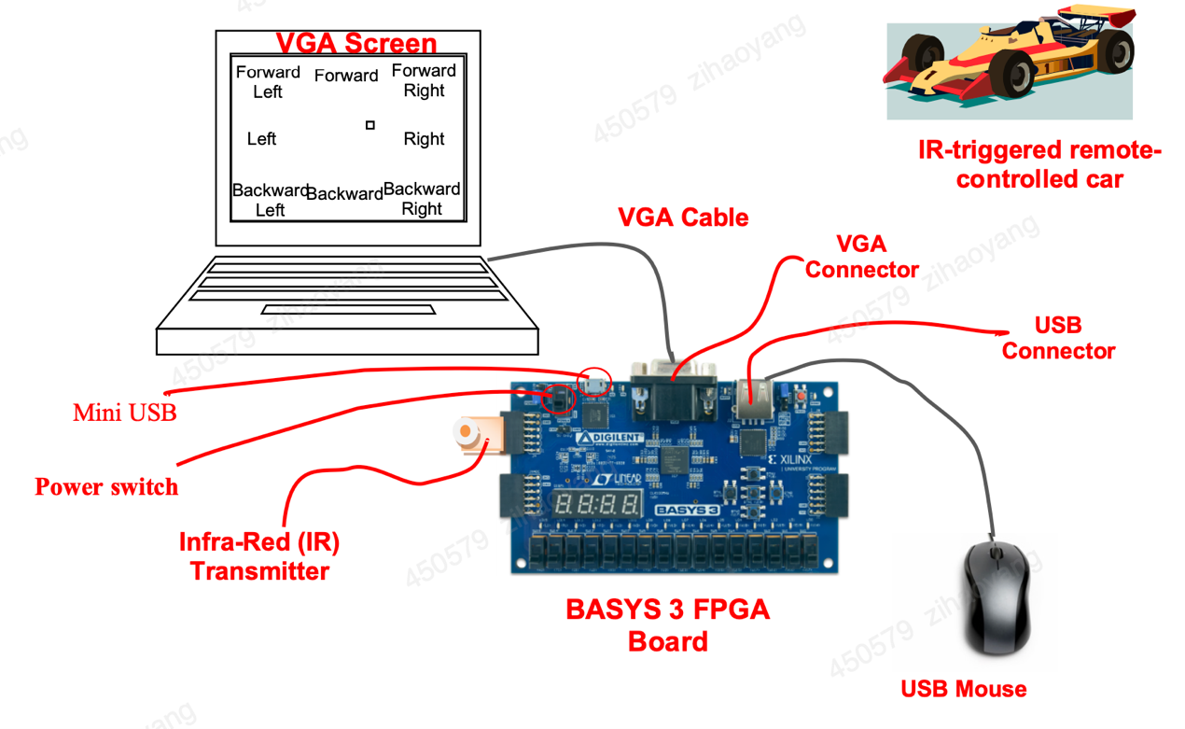

Figure 29: Overall system of remote car control

The process of synthesizing, implementing, and generating a bitstream for an FPGA is critical to translating your high-level Hardware Description Language (HDL) design into a functioning hardware configuration [21]. After generating the bitstream, open and connect the target device Basys 3 FPGA board so that the project are exported from Vivado to FPGA. And the Figure 30 displays the final performance of microprocessor-based remote car application.

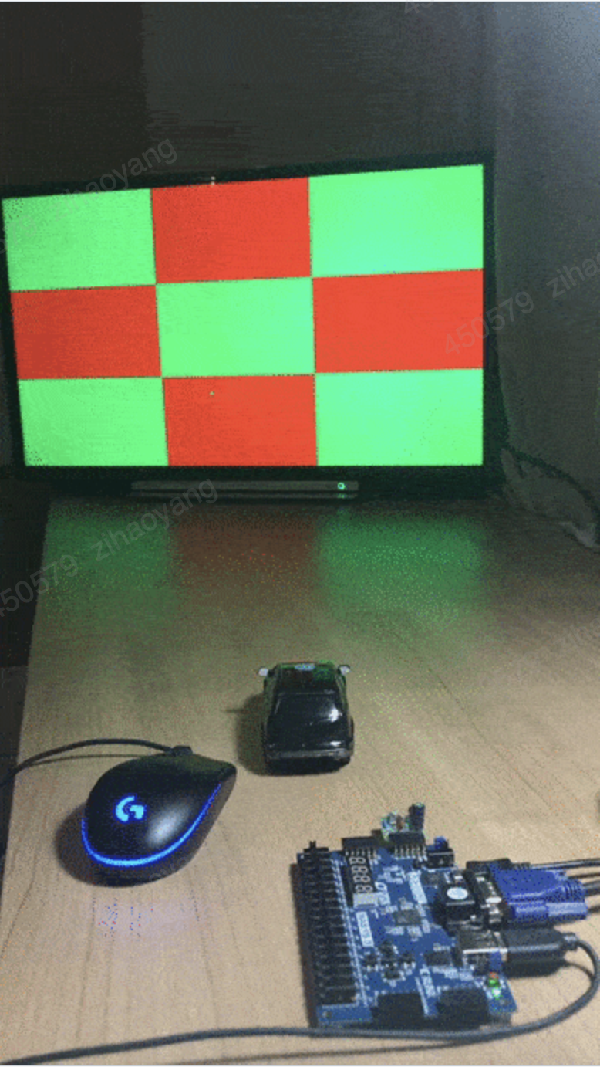

Figure 30: Car control Demo

The resource utilization is shown below

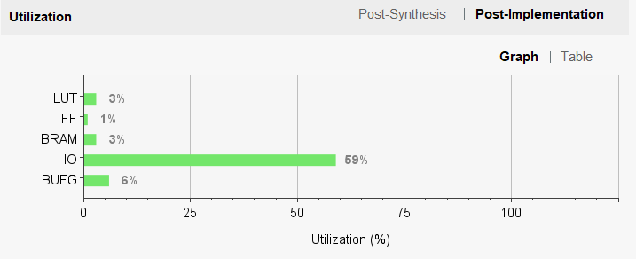

Figure 31: FPGA resource utilization

# 4, Conclusion

The implementation of a RISC-V based microprocessor on FPGA represents a significant advancement in the field of custom processor design and reconfigurable computing. This project has demonstrated the feasibility and advantages of leveraging the open-source RISC-V instruction set architecture in conjunction with the flexible and powerful capabilities of FPGA technology. Throughout this work, we have successfully designed, developed, and tested a RISC-V compliant microprocessor, showcasing the inherent benefits of this approach.

The modularity and extensibility of the RISC-V ISA allowed us to tailor the microprocessor to specific application requirements, providing a robust platform for innovation in hardware design. By utilizing HDL for detailed hardware description, synthesis tools for efficient implementation, and comprehensive verification methodologies, we ensured that the microprocessor meets stringent performance and reliability standards.

Furthermore, the adaptability of RISC-V on FPGAs facilitated rapid prototyping and iterative development, making it an ideal solution for both academic research and industrial applications. The extensive software support, including toolchain enhancements and optimized compilers, further streamlined the development process, allowing us to harness the full potential of the microprocessor.

Our benchmarking and application-specific testing highlighted notable performance gains and the ability to customize the architecture for specialized tasks, thereby validating the efficacy of our design choices. This work not only reaffirms the promise of RISC-V as a versatile and efficient ISA but also underscores the transformative potential of FPGA-based development in creating next-generation microprocessors.

In conclusion, the successful implementation of a RISC-V based microprocessor on FPGA has opened new avenues for customizable, high-performance computing solutions. This project serves as a blueprint for future endeavors, providing valuable insights and methodologies that can be leveraged by researchers and practitioners to advance the state of the art in reconfigurable computing and processor design.

# Reference

[1] M. H. Banna Saif, N. U. Sadad and M. N. Islam Mondal, "FPGA Implementation of Educational RISC- V Processor Suitable for Embedded Applications," 2023 International Conference on Electrical, Computer and Communication Engineering (ECCE), Chittagong, Bangladesh, 2023, pp. 1-5,

[2] David A. Patterson and John L. Hennessy *“Computer Organization and Design RISC-V Edition: The Hardware Software Interface.”* Page 22 Morgan Kaufmann Publishers Inc., 2017, San Francisco, CA, USA.

[3] Andrew Waterman, Krste Asanovi, and Five Inc. *“The RISC-V Instruction Set Manual Volume I: User-Level ISA Document Version 2.”* CS Division, EECS Department, University of California, Berkeley 2017

[4] RISC-V *"RISC-V GNU Compiler Toolchain"* Github 2021 https://github.com/riscv/riscv-gnu-toolchain/

[5] S. Shaikh, and S. Pujari. “Migration from microcontroller to FPGA based SoPC design: Case study: LMS adaptive filter design on Xilinx Zynq FPGA with embedded ARM controller.” International Conference on Automatic Control & Dynamic Optimization Techniques IEEE, 2016

[6] T-Y Yeh and Y.N. Patt, “Two-Level Adaptive Branch Prediction”, Technical Report CSE-TR-117-91, Computer Science & Engineering Division, Department of EECS, University of Michigan, (Nov. 1991).

[7] C. R. Baugh and B. A. Wooley, “A two’s complement parallel array multiplication algorithm,” IEEE Trans. Comput., vol. C-22, no. 12, pp. 1045–1047,Dec. 1973.

[8] Wang, Yi-Ming & Wang, Jinn-Shyan. (2004). An all-digital 50% duty-cycle corrector. Proceedings - IEEE International Symposium on Circuits and Systems. 2. II - 925. 10.1109/ISCAS.2004.1329424.

[9] Tim Wilmshurst, in Designing Embedded Systems with PIC Microcontrollers (Second Edition), 2010

[10] R. . -T. R. de J, A. Ordaz-Moreno, J. A. Vite-frias and A. Garcia-Perez, "8-bit CISC Microprocessor Core for Teaching Applications in the Digital Systems Laboratory," 2006 IEEE International Conference on Reconfigurable Computing and FPGA's (ReConFig 2006), San Luis Potosi, Mexico, 2006, pp. 1-5, doi: 10.1109/RECONF.2006.307782.

[11] S.Navalgund, Siddalingesh & Tonse, Prakash. (2013). Design, Development and Implementation of ALU, RAM and ROM for 8051 Microcontroller on FPGA using VHDL. International Journal of Computer Applications. 80. 8-14. 10.5120/13823-1280.

[12] Randall Hyde. 2003. The Art of Assembly Language. No Starch Press, USA.

[13] Scott, M. L. (2006). Programming language pragmatics Michael L. Scott. Morgan Kaufmann pub.

[14] Mansfield, R. (1983). Machine language for beginners: Machine language programming for basic language programmers. Compute! Books.

Scott, M. L. (2006). Programming language pragmatics Michael L. Scott. Morgan Kaufmann pub.

[15] Ashwini S. Deshmukh, “A Novel FPGA based Leading One Anticipation Algorithm for Floating Point Arithmetic Units” International Journal of

Reconfigurable and Embedded Systems (IJRES) Vol. 1, No. 1, March 2012, ISSN: 2089-4864, pp. 19-24. Brown, L. D., Hua, H., and Gao, C. 2003. A widget framework

for augmented interaction in SCAPE.

[16] Suma T.Hegde, Dr. Siva Yellampalli and Nandeesh R, “Design and Implementation of ALU using RedundantBinary Signed Digit”, International Conference on VLSI, Communication & Instrumentation (ICVCI) 2011, Proceedings published by International Journal of Computer Applications® (IJCA), pp: 30-35.

[17] Kenneth J Ayala, West Carolina University, “The 8051 Microcontroller, Architecture, Programming and Applications”, West Publishing Company, St Paul. ISBN 0-314-77278-2.

[18] E. Matthews, and L. Shannon . “TAIGA: A new RISC-V soft- processor framework enabling high performance CPU architectural features.” International Conference on Field Programmable Logic & Applications IEEE, 2017.

[19] H. Miyazaki, et al. “RVCoreP : An optimized RISC-V soft processor of five-stage pipelining.” (2020).

[20] E. Matthews, A. Lu, Z. Fang and L. Shannon, “Rethinking Integer Divider Design for FPGA-Based Soft-Processors,” 2019 IEEE 27th Annual International Symposium on Field-Programmable Custom Computing Machines (FCCM), 2019, pp. 289-297.

[21] Basys3 Reference Manual [Online] https://www.xilinx.com/products/design-tools/vivado.html

[22] S.Navalgund, Siddalingesh & Tonse, Prakash. (2013). Design, Development and Implementation of ALU, RAM and ROM for 8051 Microcontroller on FPGA using VHDL. International Journal of Computer Applications. 80. 8-14. 10.5120/13823-1280.